Meta Initiates Another Round of Layoffs
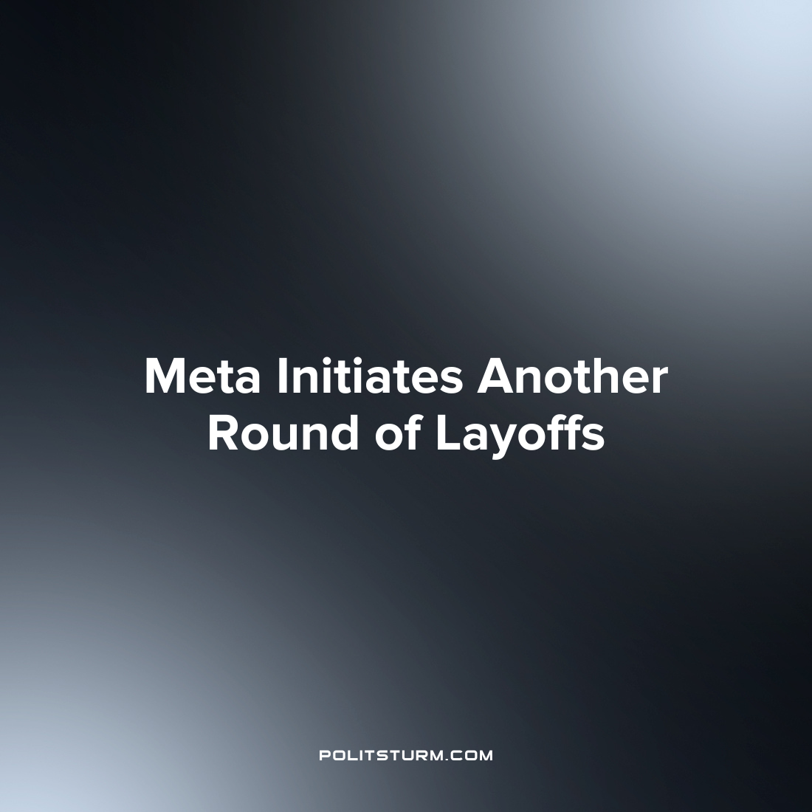

Original article
2023-05-31
2 min read

Meta initiated another round of layoffs in which an estimated 10,000 employees have lost their jobs. Meta had previously laid off 11,000 workers in November of last year as a part of Meta’s “year of efficiency” campaign to drive down operating costs. The employees who lost their jobs in the most recent round of cuts were employed in user experience, marketing, recruiting and engineering roles.
The cuts were not unknown as CEO Mark Zuckerberg had referenced these layoffs earlier in the year.
“We expect to announce restructurings and layoffs in our tech groups in late April, and then our business groups in late May. In a small number of cases, it may take through the end of the year to complete these changes. Our timelines for international teams will also look different, and local leaders will follow up with more details. Overall, we expect to reduce our team size by around 10,000 people and to close around 5,000 additional open roles that we haven’t yet hired.”, said Zuckerberg.
The capitalist class uses the word “efficient” to describe the conditions that will maximize profits. The levels of employment that maximize shareholder returns are allegedly efficient as the capitalist class extracts the maximum profit subject to the cost constraints such as wages, salaries, and all other operating costs. However, the conditions of capitalist efficiency ensure the exploitation of the workers who lose their employment through no fault of their own to serve the interests of a small group of oligarchs. The capitalist class will try to mislead and confuse the workers about the motives underlying their profit-centered decisions by talking of strategic longer-term goals and ‘difficult decisions’ which must be made to reach the common goals of a collective. However, in the end thousands of workers lose their jobs and countless more are exploited to maximize profits not for the whole of society, but for a small group of oligarchs.
Error loading image
Source: 1 2

Original article

