Memphis Starbucks Workers Fired Amid Unionization Campaign
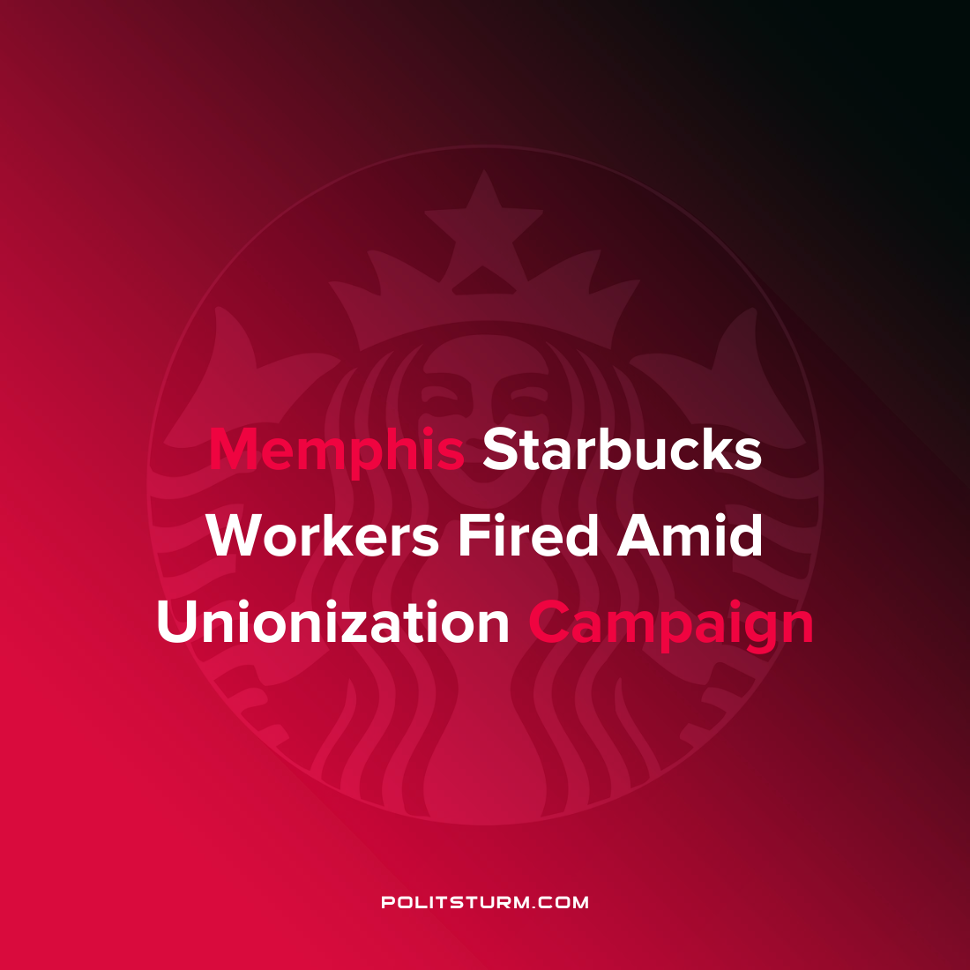

Original article
2022-02-11
1 min read

Seven Starbucks workers at a Memphis, Tennessee location claim that they were fired in retaliation for unionization efforts. The workers are claiming that Starbucks corporate leadership is targeting union leaders and firing them on trumped up charges in an effort to quell unionization efforts.
Workers are claiming that Starbucks at the Poplar and Highland store were fired soon after they went to the media to spread awareness about the unionization campaign. When questioned about the rationale about the firings of the workers, Starbucks referred to several unrelated violations as to the cause of the firings.
One of the workers who was fired and was publicly addressing the situation stated, “Never had a write up about and all of a sudden it’s an offense to get fired over! This is an outrage! They are firing the entire committee!”
Starbucks, which refers to its employees as “partners”, appears to be ramping up efforts to intimidate unionizing employees as Starbucks Workers United has workers to unionize workers across the country. It is clear that there is no partnership possible between the capitalists who derive their wealth off the unpaid labor of the workers and will protect its profit interests at all costs. The efforts of the Starbucks workers to organize despite the opposition from Starbucks is laudable. However, while organization is necessary it is also necessary to learn and apply Marxist-Leninist theory and not simply attempt to achieve gains through a “partnership” with the corporation.
Sources: 1 2 3

Original article

