Russian Healthcare Under Sanctions: Shortages of Medicines and Equipment
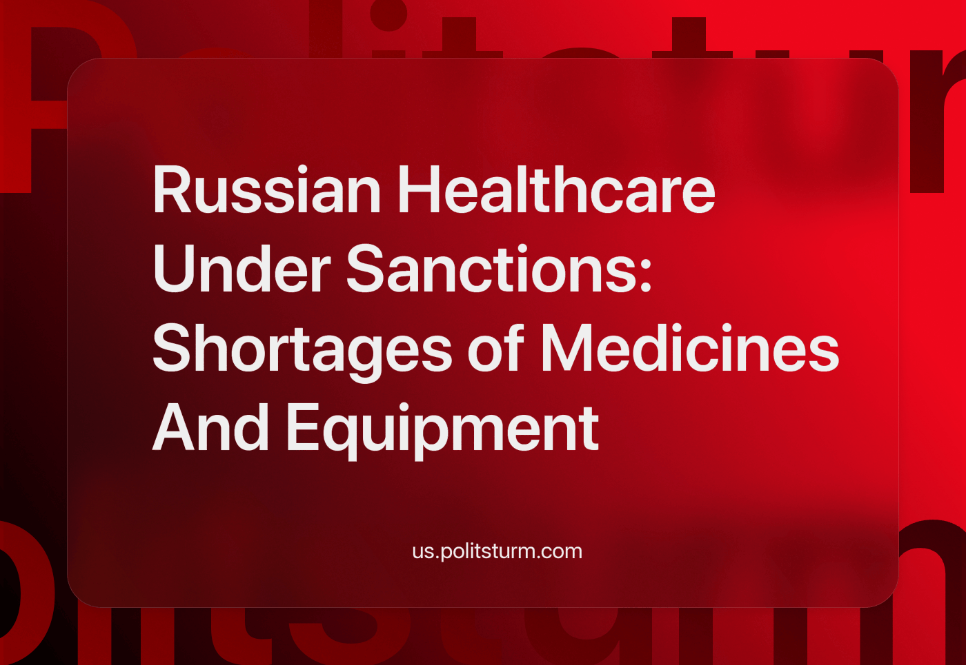

Original article
2023-12-11
8 min read

Medicine in Russia is extremely dependent on Western suppliers, so sanctions have severely damaged healthcare. The share of foreign medical devices in the Russian Federation is 79%. This figure has remained around this level since 2010, despite endless statements by the authorities about the import substitution policy.
The situation is not going to change further, because even according to populist "national projects" by 2024 the import of medical devices will be reduced to only 68%. Pharmacology around the world is monopolized by companies from the US, Sweden, other Western countries and their allies - even China does not produce the necessary drugs. What difficulties does Russian medicine face and how will it get out of them?

I. What about medical equipment?
There are no direct bans on the supply of medical equipment, but due to sanctions, there are now significant difficulties in procuring it:
1. Many parts of medical equipment fall into the category of dual-use goods, including military goods. X-ray tubes - the main part of X-ray machines and CT scanners - are considered to be such. They are also gas sensors, without which anesthesia and ventilator systems cannot function. The list of banned goods is constantly updated. The circumvention of sanctions against the Russian Federation by Western suppliers poses a risk of criminal prosecution.
2. Bank transfers from Russia to unfriendly countries are extremely difficult, sometimes even impossible. Even if a contract can be concluded, banks often freeze payment funds.
3. Logistical difficulties have increased: most international transport companies have left the Russian Federation, and some routes are unavailable for transport. There are no customary container lines, ferry lines or direct air freight. Medical equipment from Europe, the US and Japan is shipped to the RF only via intermediaries: Turkey, Dubai, Qatar and others. Experts say that it will take years to switch to new routes.
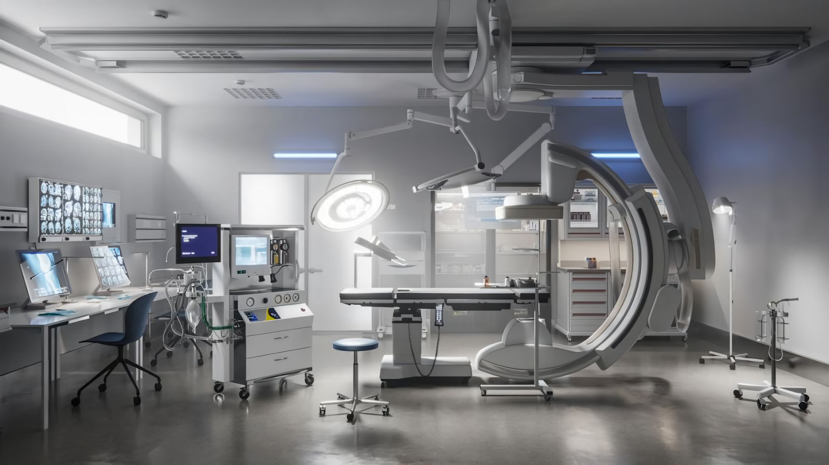
Until 2022, the Russian market for medical devices was comparable in terms of consumption of some products with the German market, one of the largest in the world. For a number of foreign manufacturers, deliveries to Russia accounted for a significant share of turnover.
These Western companies want to keep the Russian market for themselves, but the costs will be passed on to the Russian consumer. After the start of the Special Military Operation and the imposition of sanctions, foreign medical equipment went up in price by 20-70%.Russian production of medical equipment is also experiencing bad times. The reduction in foreign trade threatens to hit raw materials sharply. Only one third of all required polymers for medical equipment are produced in Russia, and importing polymers has the same difficulty as importing equipment.
It will be even more difficult to implement production expansion for import substitution of the whole Russian medical equipment market. Medical equipment manufacturing in Russia is still based on the Soviet legacy, and the success of capitalist Russia in this sector has been negligible.
Experts say that more government regulation, more government purchases, changes in the tax regime, more test labs, modernization of medical schools and universities for engineers will be needed to develop the industry. At the same time, we do not see any suggestion that the government is ready for such a large-scale policy.

II. What about the medication?
The Western sanctions have not affected the pharmaceutical industry, but it has become more expensive to import due to difficulties with logistics, and therefore a number of international companies have curtailed business in Russia.
"At some point, relatively inexpensive drugs supplied by international pharmaceutical companies will either be manufactured in Russia or will not be brought into our country. It becomes more expensive to deliver a package of pills with a lot of air in it than to bring in a substance and make the same pill from it, even if you build a plant for that purpose. So now it has become so expensive to bring a cheap drug from India to Russia that it may be more profitable to build a plant here." – says the general director of Binnopharm Group.
The pharmaceutical industry will actually have to be created from scratch, because the Soviet industry, which in addition to the Soviet Union supplied all the countries of the Warsaw Pact, has already been destroyed, and it is not possible to create our own. If medicines are created in Russia from scratch, they will be very expensive. According to preliminary estimates, the creation of substances alone will be 3-4 times more expensive than imported ones.
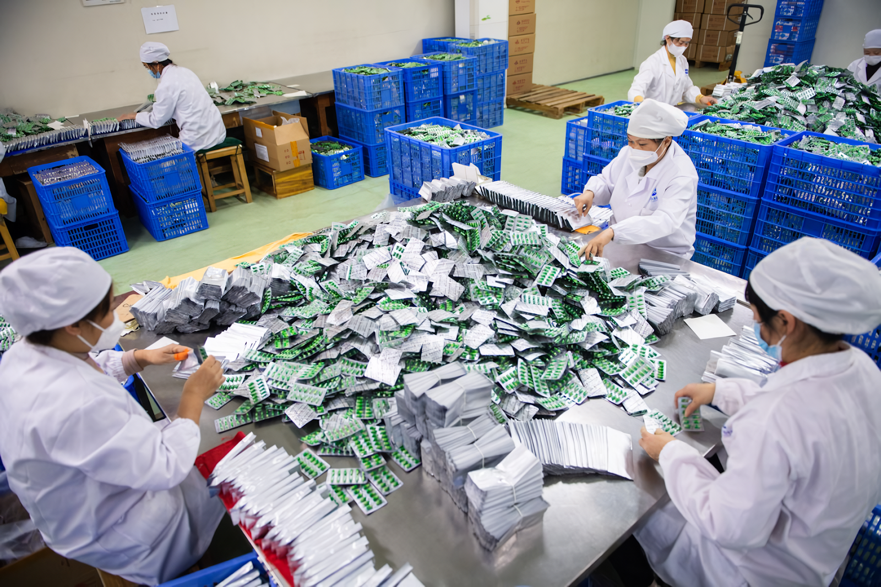
In order to produce drugs profitably, Russia will need mass production of every kind of raw material, which in capitalist conditions requires a huge market, and even the domestic Russian and CIS market is too small.
Even China does not provide drugs for itself. Their market, like Russia's, is dominated by "big pharma" made up of American and European suppliers. Chinese production is export-oriented, and contrary to myths, less than a third of the population is treated with "Chinese folk medicine" in China.
Russian pharmaceutical producers are also export oriented. The Russian pharmaceutical business cannot gain a foothold in NATO countries in the current political climate; also these countries have a strong hold on the Latin American market, with the exception of Nicaragua, Cuba and Venezuela, but their pharmaceutical businesses are considered insolvent.
Today, Russian producers are trying to penetrate the markets of Arab countries, Southeast Asia, Africa and China. At the same time, we are not yet talking about localization of production, i.e. acquisition of plants abroad. With the current scale of Russian pharmacology, it will be profitable to pay for production in other countries either with state orders, the size of which industry representatives are counting on only in Kazakhstan and Belarus, or with the growth of turnover with China.
The Chinese market seems very attractive for Russian pharmaceutical manufacturers. Because of the common border, they expect minimal problems with transportation, and the market in just one major Chinese province is comparable with the whole of Russia. However, Russian pharmaceutical manufacturers are slow to penetrate into China due to having little experience with the local culture, legislation and banks.
Vladimir Putin promised back in 2008 to make Russia the world leader in information, bio- and nanotechnology by 2017. In the same year he promised that the medical sector would develop so much that medical institutions would have to compete with each other for patients. In 2011. Medvedev admitted that import substitution measures were ineffective, and in 2014 Putin said that instead of the expected breakthrough in 2012, Russia is critically dependent on imported equipment.
Experience has shown that the Russian authorities' claim of import substitution of medical devices under capitalism is a deception. Only under a socialist system, when the pursuit of profit is replaced by concern for society, will the Russian people wait for affordable and high-quality medicine.
Sources
RBC Pro - Medical equipment shortages are a risk. Is its import substitution possible in Russia - from May 17, 2022
Kommersant - "The process of medical equipment supplies to Russia has become very complicated over the past year" - from March 20, 2023.
Vedomosti - Imported medical equipment and materials increased in price by 20-70% - from March 5, 2022
Kommersant - Russia lacks plastics - from April 5, 2023
Kommersant - "Drug safety of the country is important, but it is very expensive" - April 27, 2023
Rossiyskaya Gazeta - By 2020 Russians will earn $2,700 a month - March 18, 2008.
GARANT. RU - Import substitution policy in Russia: from words to deeds - from June 9, 2015.

Original article

