Meatpacking Companies Adopt Worker Surveillance Technologies
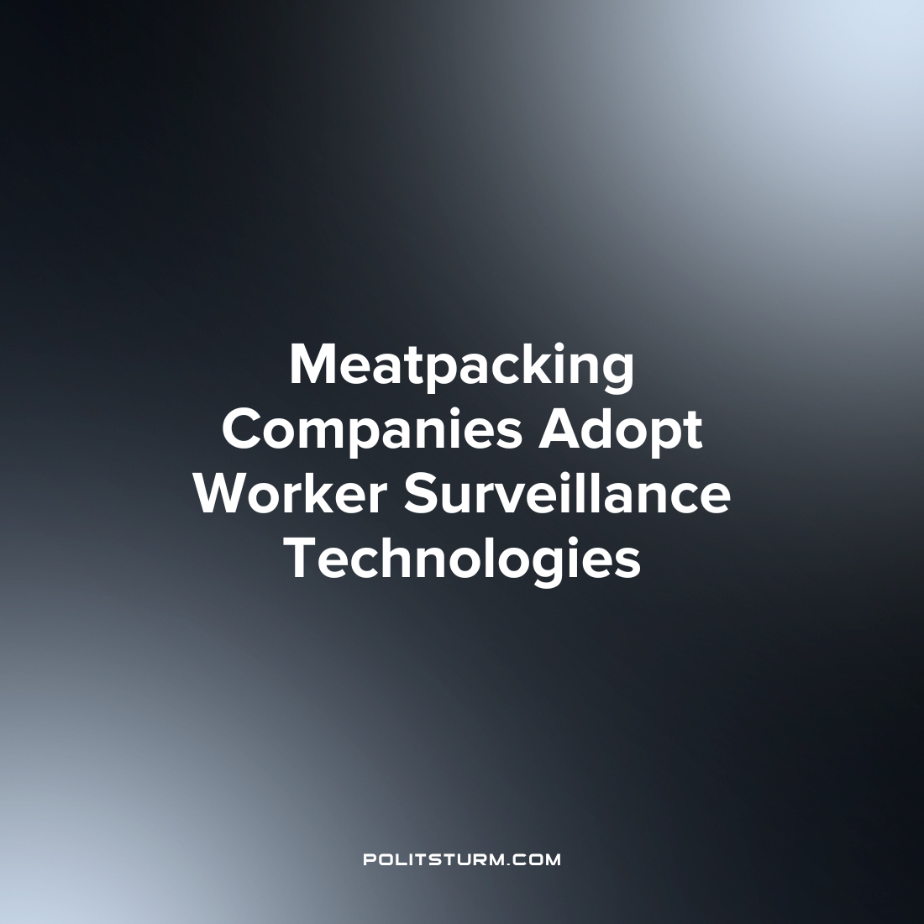

Original article
2022-10-13
1 min read

According to investigative journalism from Investigate Midwest, two of America’s largest meatpacking companies have invested in a smartwatch application which will allow them to track employee movements in real-time. The developer of the application, Mentore, claims that the application will improve productivity and will help to reduce the number of workplace injuries.

“Our hypothesis is that if you have implemented good, safe methods for the workers, they are going to be productive as well…What we demonstrate to our customers is that, ‘Hey, we fix your training and safety concerns and see — your workforce is happier, more productive, efficient, and they stay longer.’ That’s what the approach is, not the other way around”, says co-founder and Mentore CEO Apoorva Kiran.
Mentore was initially funded by Tyson ventures, the venture capitalist branch of Tyson Foods in addition to Monozukuri Ventures and the Threshold Impact Fund. A smartwatch with the Mentore application feeds information into an AI algorithm which converts the data into metrics which is then visible to supervisors in real-time. In addition to metrics related to worker safety, the application will allow supervisors to track work intensity and productivity.
Under the capitalist economic system, “efficiency” and “productivity” are used to describe conditions which create the maximum profit for the capitalist class. The implementation of this technology is intended to give the capitalist class more tools to exploit the workers, the majority of which are foreign-born U.S. workers already subject to exploitative conditions. Under the capitalist economic system the gains of technology are restricted by the profit motive and any productivity improvements will serve the interests of the oligarchs, and not the whole society.
Source: 1

Original article

