Meat Packing Workers Face Serious Injuries Amid Loosening Regulations
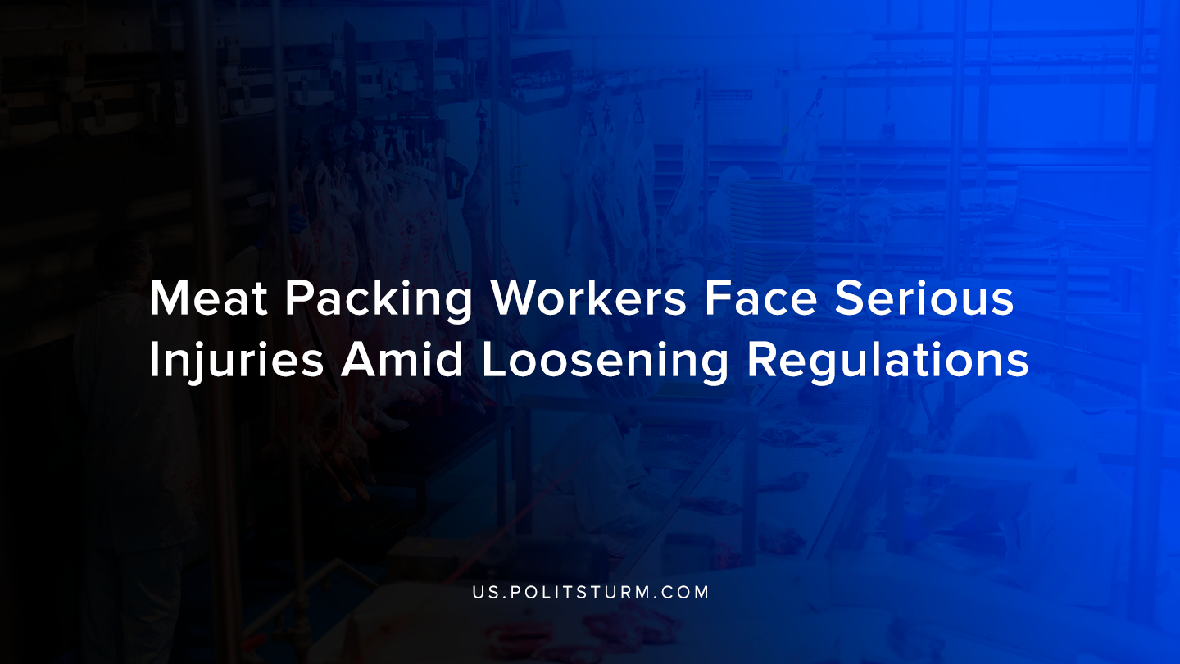

Original article
2019-09-27
1 min read

A new report by Human Rights Watch found that meat-packing workers were at risk of serious, life threatening injuries and illnesses from work-related injuries. The report interviewed workers who primarily work in Nebraska, Alabama, and North Carolina at plants owned by 12 different companies.
The report found that workers had musculoskeletal illnesses from the rapid, repetitive movements required by meat and poultry slaughtering and processing procedures. In addition, workers reported difficulty in obtaining adequate health care to treat their conditions.
The Trump administration has acted to give more discretion to meat processing and packaging plants and thereby loosening oversight. The Occupational Safety and Health Administration (OSHA) is working with the fewest safety and health inspectors in its history.
The report says that the interviewed workers talked about harsh working conditions and long hours without breaks. Also, workers suffered from scars, missing fingers, and swollen joints caused by their work.
In an effort to increase the intensity of work and thereby profits, the capitalists cause great trauma to the workers. Under capitalism the worker’s ability to work is a commodity sold to the capitalist who is driven by competition to maximize profits. The needs and wellbeing of the workers are subordinated to the profit motive. The loosening of regulations by OSHA under the Trump administration makes the ruthless, exploitative nature of the meatpacking and processing industry more visible.
Sources: 1, 2

Original article

