MBTA Proposes Transit Cuts Amidst Pandemic
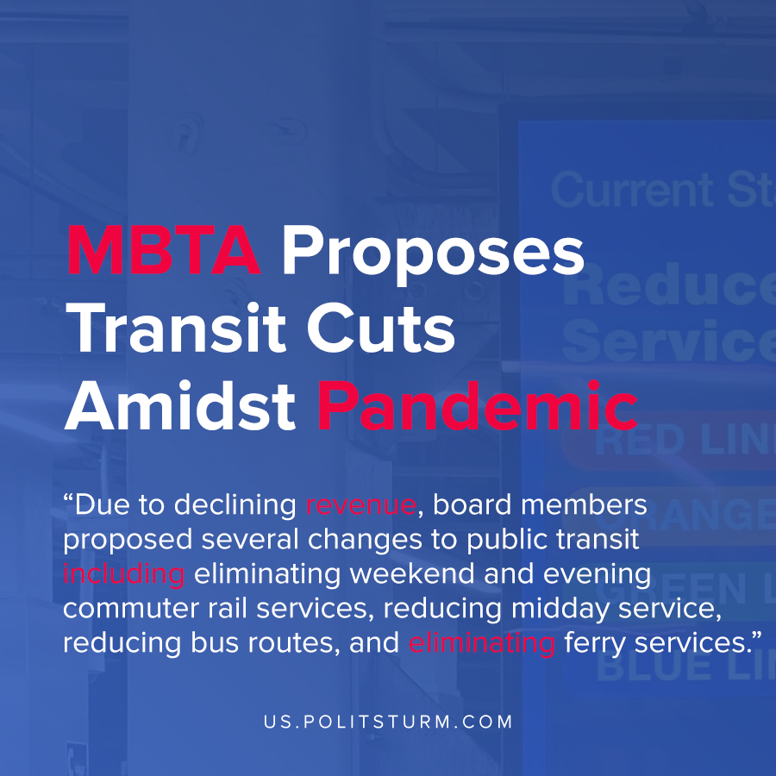

Original article
2020-12-08
1 min read

In the midst of declining ridership during the pandemic and economic crisis, the Massachusetts Bay Transit Authority (MBTA) had a board meeting to discuss proposed changes. According to preliminary statistics released by the MBTA, bus ridership plummeted to about 20% of normal ridership levels between March and April 2020. Other forms of transportation were similarly affected.
Due to declining revenue, board members proposed several changes to public transit including eliminating weekend and evening commuter rail services, reducing midday service, reducing bus routes, and eliminating ferry services.
Many riders indicated their dissatisfaction with the proposals and how it would affect their daily lives and commute.
“Eliminating all weekend service is cutting off essential workers who commute on a rotating schedule. For example, hospital staff like nurses have rotating schedules outside of a standard M-F 9-5… Providence is a significant commuting hub and it would be doing healthcare workers a disservice to make their commute significantly harder as long as the pandemic continues”, said one commenter.
Due to the capitalist organization of public transportation the United States, municipalities have to pay interest and debt expenses to the bondholders. As such, the decisions of the board of trustees are fundamentally structured with the same profiteering motivations that govern private enterprises.
The steep decline in revenues has prompted the MBTA to make cuts that will reduce service and crowd the existing infrastructure during a pandemic, all to appease the idle rich.
Sources: 1 , 2 , 3

Original article

