Mass Layoffs Signal a Deepening Crisis of Overproduction
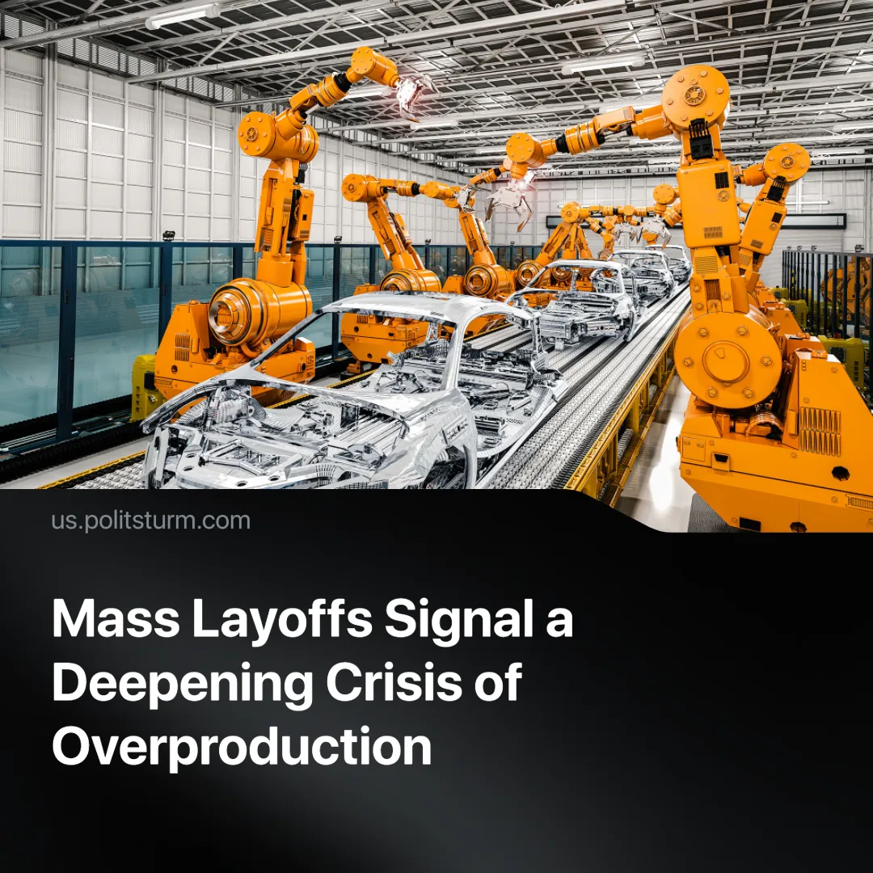

Original article
2025-04-07
2 min read

Major corporations are carrying out mass layoffs, justified by talk of “efficiency”. But the real cause lies in capital’s inability to profitably sell what it produces. The result is a crisis of overproduction: goods pile up unsold, even as millions remain unemployed and increasingly impoverished.
Details. Firms across the globe are laying off workers and planning deeper cuts for 2025. Business analysts forecast continued redundancies, attributing them to labor market “adjustments.”
► In Europe, large firms are downsizing: Swedish telecom group TELE2 will cut 600 jobs; German biotech firm BioNTech, up to 1,350; Porsche, 2,000; Continental’s automotive division, 3,000; British oil and gas giant BP, 4,700; and logistics giant DHL, 8,000.
► In the U.S., UPS laid off 12,000 workers in 2024, with plans to reach 22,000 by 2025. Other major firms announcing cuts include Goldman Sachs, Starbucks, Blue Origin, and Estée Lauder.
► In China, automobile company Li Auto cut over 5,600 employees in 2024. Alibaba announced a 7% staff cut. Huya and Douyu, two major streaming platforms, have also begun layoffs.
Context. The crisis reflects growing contradictions in global capitalist production: a decline in demand, rising costs, and a turn to automation to preserve profits.
► Global Gross Domestic Product (GDP) growth continues to slow — The OECD projects global GDP to slow from 3.2% in 2024 to 3.0% by 2026.
► Inventories are rising across sectors — retail, manufacturing, automotive — while global consumer demand stagnates or declines, forcing companies into overstock positions and deepening the crisis of overproduction.
► Central banks have raised interest rates to combat inflation, reducing credit access and consumer spending.
► Capital turns to AI and automation to reduce wage costs, replacing living labor with fixed capital even as markets for output narrow.
Important to know. These layoffs are not a result of technological inevitability or mismanagement but of capitalist overproduction. Capitalism cannot sell its output profitably—not because goods aren’t needed but because they can’t be sold at a profit.
► Workers are not dismissed because there is no work to be done but because capital is unable to realize surplus-value. Living labour is sacrificed first—it is more easily disposed of—while constant capital is often preserved or expanded in an attempt to stay competitive, even as this deepens the crisis.
► As companies replace workers with machines, they reduce wage costs but weaken the very source of profit—labor-power. Over time, this makes it harder to maintain profitability, pushing the system into further crisis.
► With fewer workers earning wages, they can afford less of what they themselves produce. This shrinks demand, leaves commodities unsold, and intensifies the crisis of overproduction.
► Capitalist media will likely present the crisis as a result of mismanagement, tariffs, market volatility, or external shocks—hiding its basis in capitalist contradictions. As in 2008, overproduction and falling profitability will be ignored in favor of surface-level narratives that preserve faith in the system and deflect attention from its structural failures.
Conclusion. Workers will bear the consequences—not only economically but politically. While monopolies restructure, automate, and receive state support, the working class faces rising unemployment, falling living standards, and intensified repression. Under the pretext of “fiscal discipline,” governments will impose deeper social cuts, while any resistance will be criminalized. But this crisis, like those before it, reveals the absurdity of capitalism: too much is produced for profit while millions live in poverty.
Such crises are not inevitable—they are the outcome of a system based on private ownership and profit. They can and must be overcome. Only a socialist system—based on social ownership and production for need—can put an end to these contradictions.

Original article

