National Self-Determination: The Marxist-Leninist Approach


Original article
2024-09-02
9 min read

The question of the nation and the right of nations to self-determination occupies a central place in Marxist-Leninist theory. A correct understanding of the national question is crucial for communists. We have compiled quotes from the classics that clarify the essence of the Marxist approach to nations and the question of self-determination.

What Is a Nation?
“A nation is a historically constituted, stable community of people, formed on the basis of a common language, territory, economic life, and psychological make-up manifested in a common culture.” – I.V. Stalin, Marxism and the National Question, Chapter I, The Nation
What is meant by the self-determination of nations?
“If we want to grasp the meaning of self-determination of nations, not by juggling with legal definitions, or “inventing” abstract definitions, but by examining the historico-economic conditions of the national movements, we must inevitably reach the conclusion that the self-determination of nations means the political separation of these nations from alien national bodies, and the formation of an independent national state.” – V.I. Lenin, The Right of Nations to Self-Determination, Chapter I
“The right of self-determination means that only the nation itself has the right to determine its destiny, that no one has the right forcibly to interfere in the life of the nation, to destroy its schools and other institutions, to violate its habits and customs, to repress its language, or curtail its rights.” – I.V. Stalin, Marxism and the National Question, Chapter II, The National Movement

Why Do Communists Support the Right of Nations to Self-Determination?
Opportunists portray the cause of national liberation as something that communists must support due to abstract “historical justice”, or “solidarity”.
In reality, communists support it to implement the principles of proletarian internationalism and overcome national prejudices. This is necessary for the strongest possible unification of workers of different countries and nationalities in the struggle against capitalism. This is the main goal.
“The proletariat of the oppressing nations cannot confine itself to the general hackneyed phrases against annexations and for the equal rights of nations in general, that may be repeated by any pacifist bourgeois. The proletariat cannot evade the question that is particularly “unpleasant” for the imperialist bourgeoisie, namely, the question of the frontiers of a state that is based on national oppression.
The proletariat cannot but fight against the forcible retention of the oppressed nations within the boundaries of a given state, and this is exactly what the struggle for the right of self-determination means. The proletariat must demand the right of political secession for the colonies and for the nations that “its own” nation oppresses. Unless it does this, proletarian internationalism will remain a meaningless phrase; mutual confidence and class solidarity between the workers of the oppressing and oppressed nations will be impossible; the hypocrisy of the reformist and Kautskyan advocates of self-determination who maintain silence about the nations which are oppressed by “their” nation and forcibly retained within “their” state will remain unexposed.
The Socialists of the oppressed nations, on the other hand, must particularly fight for and maintain complete, absolute unity (also organizational) between the workers of the oppressed nation and the workers of the oppressing nation.
Without such unity it will be impossible to maintain an independent proletarian policy and class solidarity with the proletariat of other countries in the face of all the subterfuge, treachery and trickery of the bourgeoisie; for the bourgeoisie of the oppressed nations always converts the slogan of national liberation into a means for deceiving the workers; in internal politics it utilizes these slogans as a means for conducting reactionary agreements with the bourgeoisie of the ruling nation (for instance, the Poles in Austria and Russia, who entered into pacts with reaction in order to oppress the Jews and the Ukrainians); in the realm of foreign politics it strives to enter into pacts with one of the rival imperialist powers for the purpose of achieving its own predatory aims (the policies of the small states in the Balkans, etc.).” – V.I. Lenin, The Socialist Revolution and the Right of Nations to Self-Determination.
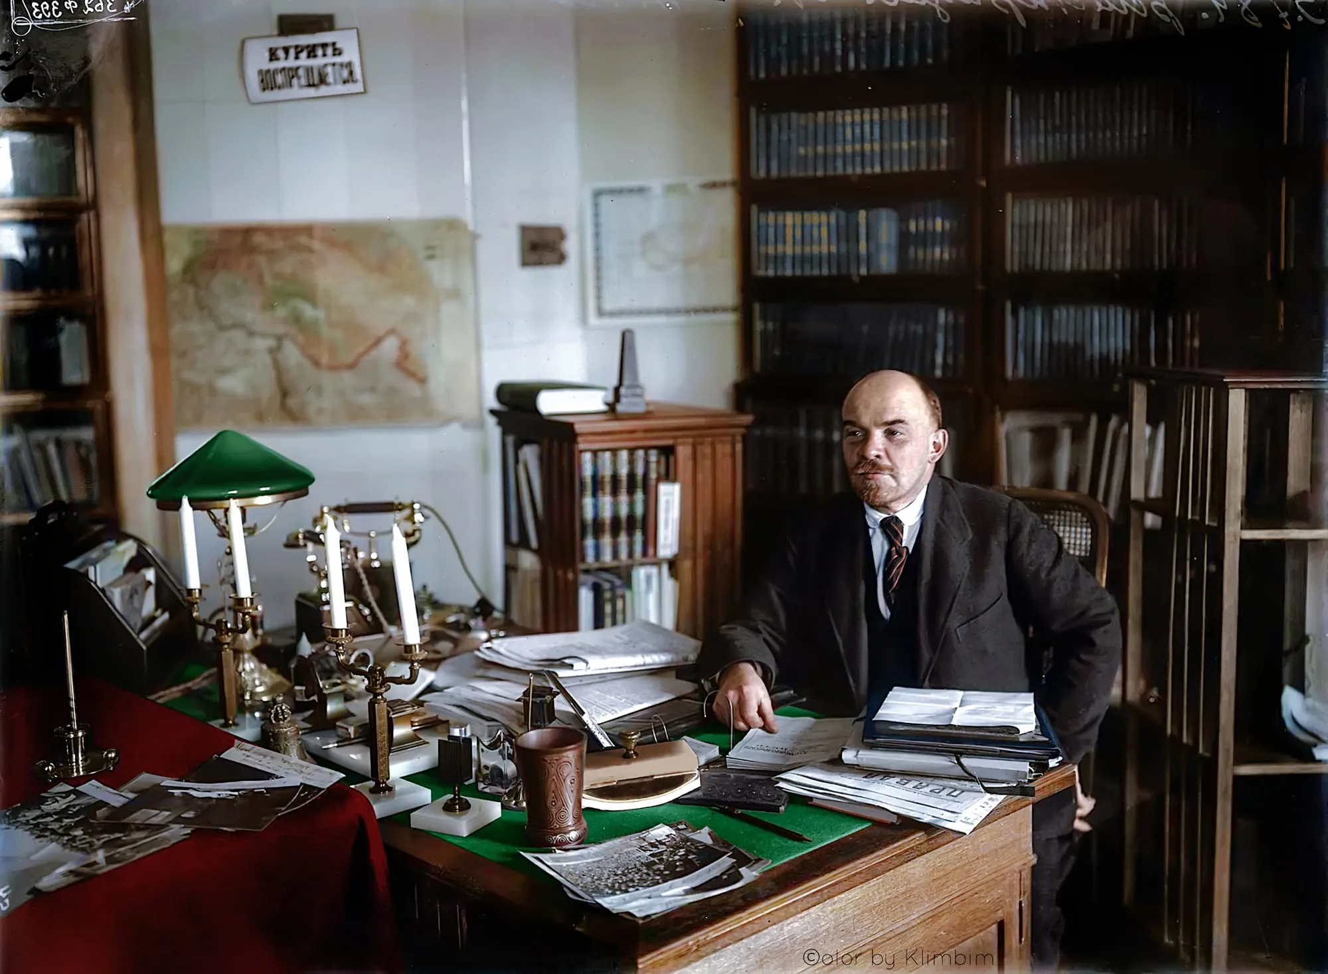
Vladimir Lenin in his Kremlin office, October 1922

As Lenin correctly notes, the bourgeoisie of oppressed nations actively uses the slogans of national liberation to deceive workers and propagate their nationalism and chauvinism.
Today, imperialist blocs are fighting for the redivision of the world. In almost every country, there are political groups proclaiming the necessity of a “national liberation struggle”, which in reality turns out to be a struggle for a transition from one bloc to another (e.g., from the US and EU bloc to the Chinese bloc, and vice versa).

Do Communists Always Support National Movements?
Various kinds of deviationists often conclude that communists should support every nation striving for separation and every (or almost every) demand of these nations. Is this really the case? Let us turn to Stalin's analysis.
“Nations have a right to arrange their affairs as they please; they have a right to preserve any of their national institutions, whether beneficial or harmful – nobody can (nobody has a right to!) forcibly interfere in the life of a nation. But that does not mean that Social-Democracy will not combat and agitate against the harmful institutions of nations and against the inexpedient demands of nations. On the contrary, it is the duty of Social-Democracy to conduct such agitation and to endeavour to influence the will of nations so that the nations may arrange their affairs in the way that will best correspond to the interests of the proletariat. For this reason Social-Democracy, while fighting for the right of nations to self-determination, will at the same time agitate, for instance, against the secession of the Tatars, or against cultural-national autonomy for the Caucasian nations; for both, while not contradicting the rights of these nations, do contradict "the precise meaning" of the programme, i.e., the interests of the Caucasian proletariat…
… But it follows that the esteemed conference most unpardonably muddled two entirely different things. The result obtained was not a solution of the national question but an absurdity, according to which the rights of nations and the principles of Social-Democracy "do not contradict" each other, and, consequently; every demand of a nation may be made compatible with the interests of the proletariat; consequently, no demand of a nation which is striving for self-determination will "contradict the precise meaning" of the programme!” – I.V. Stalin, Marxism and the National Question, Chapter VI, The Caucasians, The Conference of the Liquidators
Since communists prioritise the interests of the working class above all, when determining their position on the national question in each individual case, they strive to take a position that best serves those interests.
The correct position should help communists maximise the unity of workers from different countries and nationalities in the struggle against the capitalist class, counteract bourgeois propaganda of nationalism, chauvinism, and racism, and implement the principles of proletarian internationalism.
“The proletariat is opposed to such practicality. While recognising equality and equal rights to a national state, it values above all and places foremost the alliance of the proletarians of all nations, and assesses any national demand, any national separation, from the angle of the workers’ class struggle. This call for practicality is in fact merely a call for uncritical acceptance of bourgeois aspirations.” – V.I. Lenin, The Right of Nations to Self-Determination, Chapter IV, “Practicality” in the National Question
Many modern opportunists and revisionists forget about this. Mindlessly supporting various slogans, they turn into free (and often paid) agents of the imperialists. See our material “Communists and the Palestinian Question” for a more detailed analysis of such actions using the Palestinian conflict as an example.
“Imperialism is as much our “mortal” enemy as is capitalism. That is so. No Marxist will forget, however, that capitalism is progressive compared with feudalism, and that imperialism is progressive compared with pre-monopoly capitalism. Hence, it is not every struggle against imperialism that we should support. We will not support a struggle of the reactionary classes against imperialism; we will not support an uprising of the reactionary classes against imperialism and capitalism.” – V.I. Lenin, A Caricature of Marxism and Imperialist Economism, Chapter V, “Monism And Dualism”

Capitalists Supported Nationalists Against the Soviet Union
History provides many examples of the worst reactionaries who masked their expansion with slogans of “national freedom” and “self-determination” and also used them against communism and the freedom of workers.
For example, many White Guards (in countries like Poland and Finland) fought against the Bolsheviks during the Civil War for their “national freedom” (i.e., freedom for their national bourgeoisie to exploit “their” workers).
In the 1930s, Nazi Germany used the conflict over the Sudeten Germans in Czechoslovakia to justify imperialist expansion in Europe.
Similarly, the “liberation” movements of Nazi collaborators during World War II operated under the banners of “self-determination”, such as the Ukrainian Insurgent Army (UPA), the Russian Liberation Army (ROA) and different Caucasian and Asian regiments made of former Soviet soldiers.
During the Cold War, the American bloc actively supported the nationalist underground in the USSR under slogans about “national liberation” and the “struggle for independence”. Finally, the counter-revolutionary forces in the Soviet Republics in the late 1980s and early 1990s also operated under the slogans of “national liberation”.

Conclusion
As is evident, while communists advocate for the principle of the right to self-determination, the conditions under which Marxists support a particular national struggle are determined by its class character, the class independence of the workers' movement, and whether it strengthens proletarian internationalism and the international struggle for socialism.
At the same time, they categorically oppose reactionary forces that hide behind slogans of national freedom for their bourgeois interests. The rush to blindly support every group of “freedom fighters”, regardless of their class character, contradicts Marxism-Leninism.
In each individual case, communists should not blindly accept rhetoric about the “struggle for liberation”, but analyse the specific forces and conditions, including the international context.

Original article

