Marx on the Immediate Struggle as the National Struggle
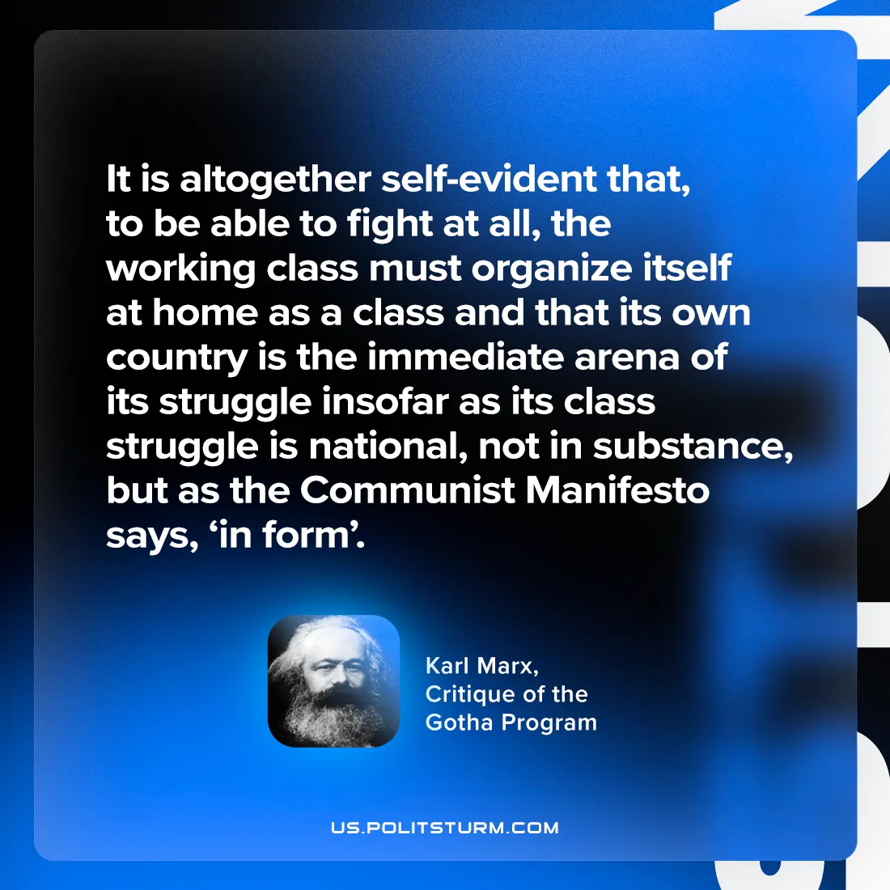

Original article
2024-08-03

"It is altogether self-evident that, to be able to fight at all, the working class must organize itself at home as a class and that its own country is the immediate arena of its struggle — insofar as its class struggle is national, not in substance, but, as the Communist Manifesto says, ‘in form’.”
Karl Marx, Critique of the Gotha Program

Original article

