Marx on Truth and Practice
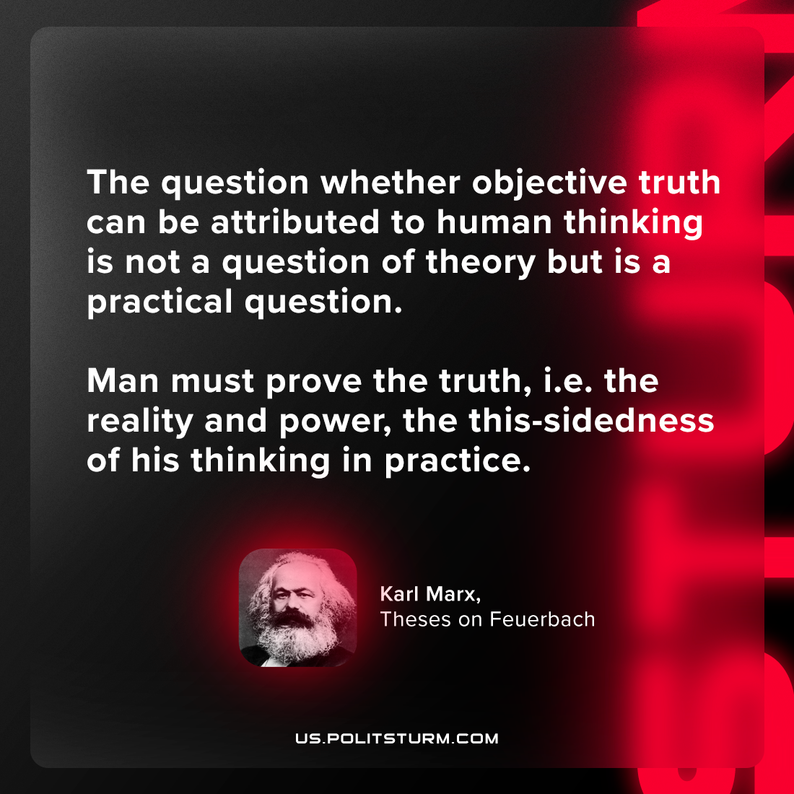

Original article
2024-05-14

"The question whether objective truth can be attributed to human thinking is not a question of theory but is a practical question. Man must prove the truth — i.e. the reality and power, the this-sidedness of his thinking in practice."
Karl Marx, Theses on Feuerbach

Original article

