Marx on Trades Unions
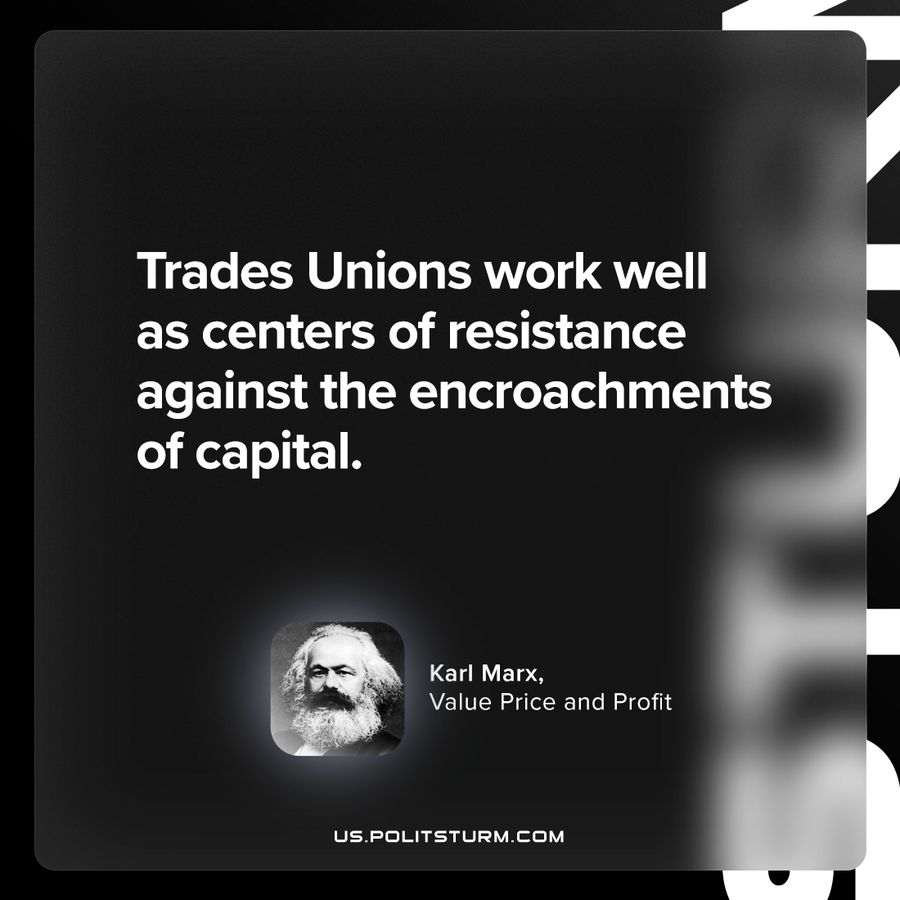

Original article
2023-12-12

"Trades Unions work well as centers of resistance against the encroachments of capital."
Karl Marx, Value, Price, and Profit

Original article

