Marx on Trade Unions, Economic and Political Struggle
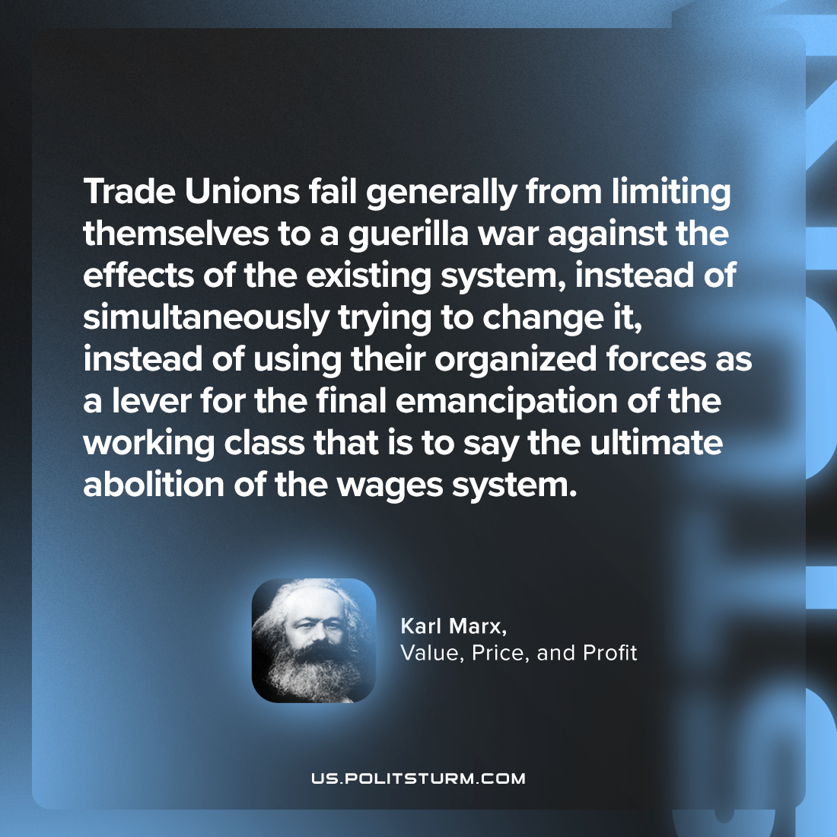

Original article
2024-01-01

"Trade Unions fail generally from limiting themselves to a guerilla war against the effects of the existing system, instead of simultaneously trying to change it, instead of using their organized forces as a lever for the final emancipation of the working class that is to say the ultimate abolition of the wages system."
Karl Marx, Value, Price, and Profit

Original article

