Marx on the Will of the Capitalist
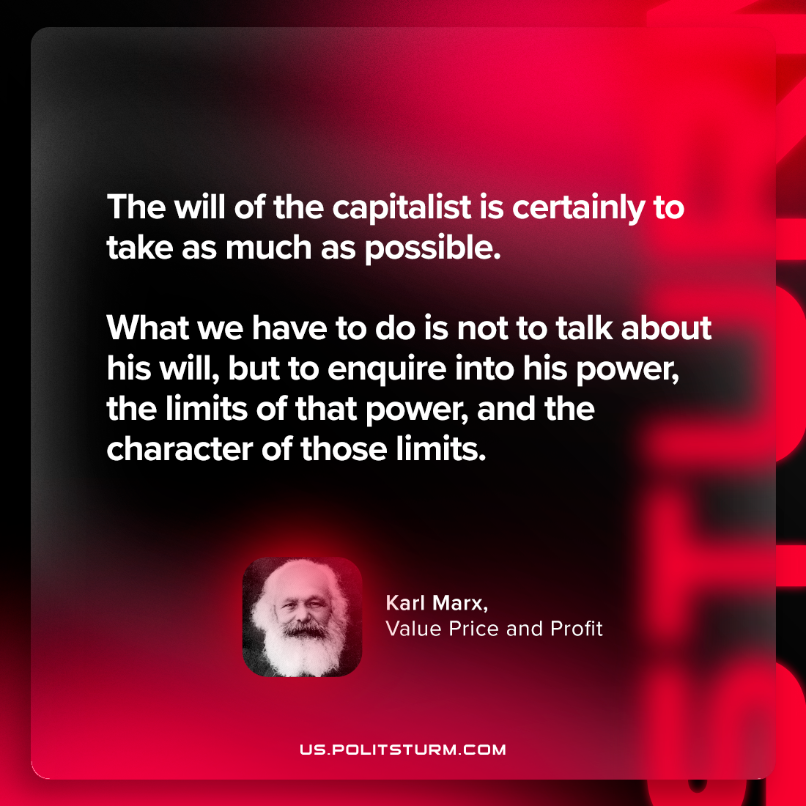

Original article
2024-03-14

“The will of the capitalist is certainly to take as much as possible. What we have to do is not to talk about his will, but to enquire into his power, the limits of that power, and the character of those limits.”
Karl Marx, Value Price and Profit

Original article

