Marx on the Struggle of the Proletariat with the Bourgeoisie
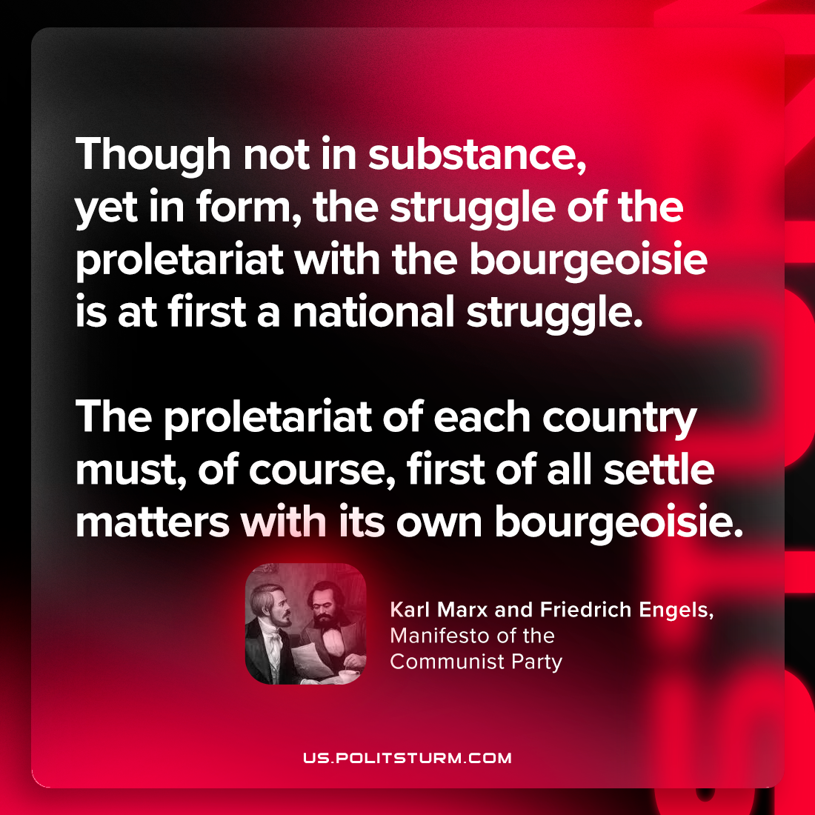

Original article
2023-11-12

"Though not in substance, yet in form, the struggle of the proletariat with the bourgeoisie is at first a national struggle. The proletariat of each country must, of course, first of all settle matters with its own bourgeoisie."
Karl Marx and Friedrich Engels, Manifesto of the Communist Party

Original article

