Marx on the Relationship between Capitalist and Industry
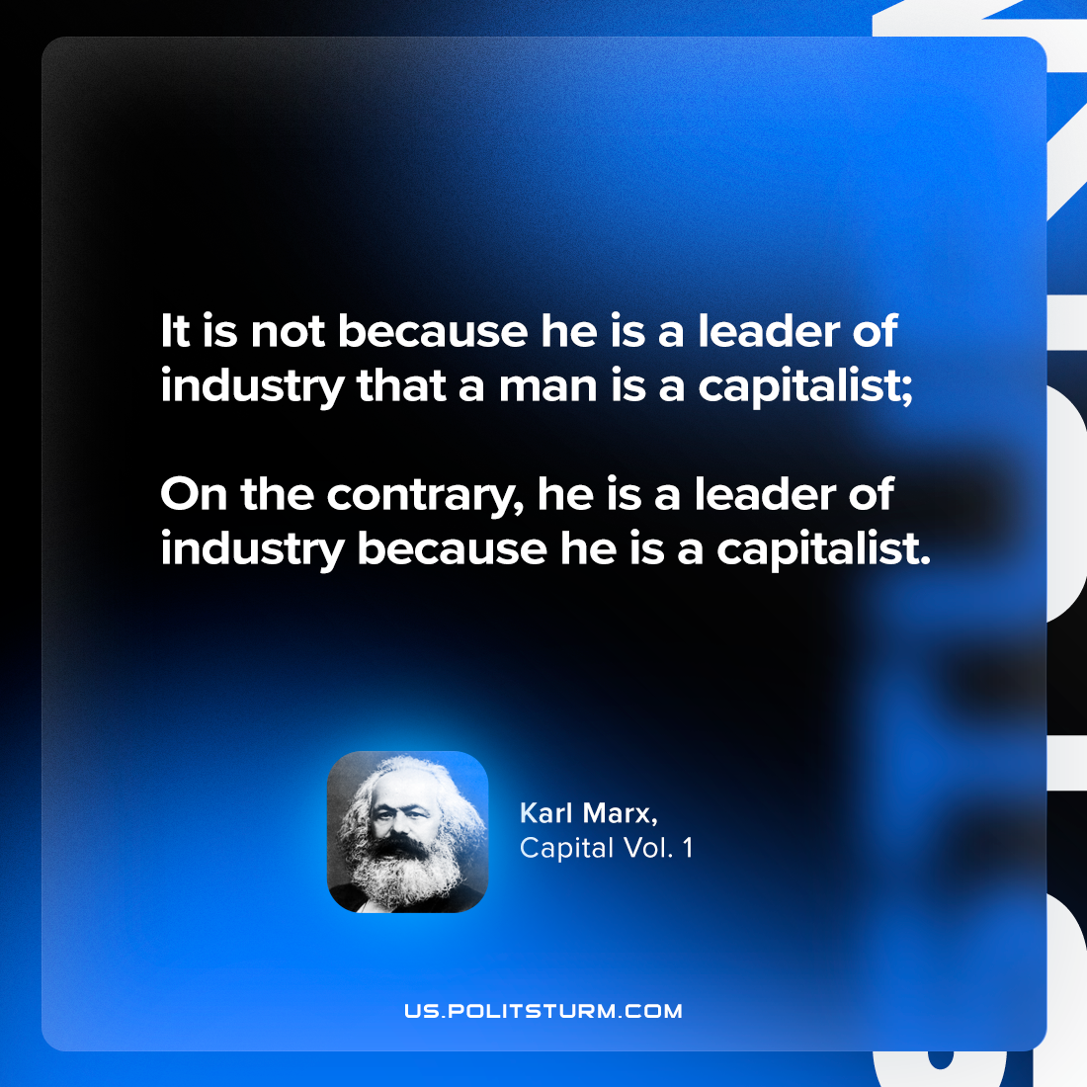

Original article
2024-03-09

"It is not because he is a leader of industry that a man is a capitalist; on the contrary, he is a leader of industry because he is a capitalist."
Karl Marx, Capital Vol. 1

Original article

