Marx on the Instruments of Labour
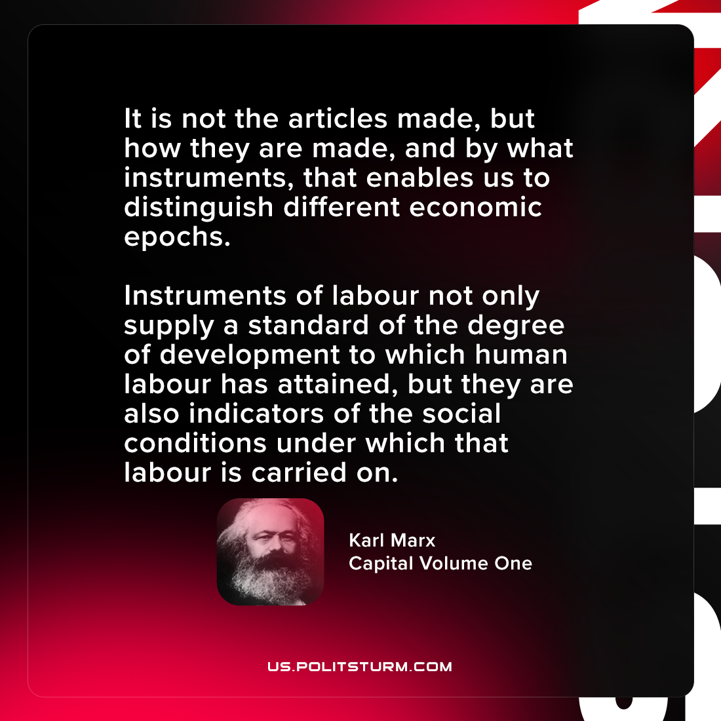

Original article
2021-08-23

It is not the articles made, but how they are made, and by what instruments, that enables us to distinguish different economic epochs. Instruments of labour not only supply a standard of the degree of development to which human labour has attained, but they are also indicators of the social conditions under which that labour is carried on.

Karl Marx, “Capital Volume One: Part 3”

Original article

