Marx on the Inevitable Fall of the Bourgeoisie
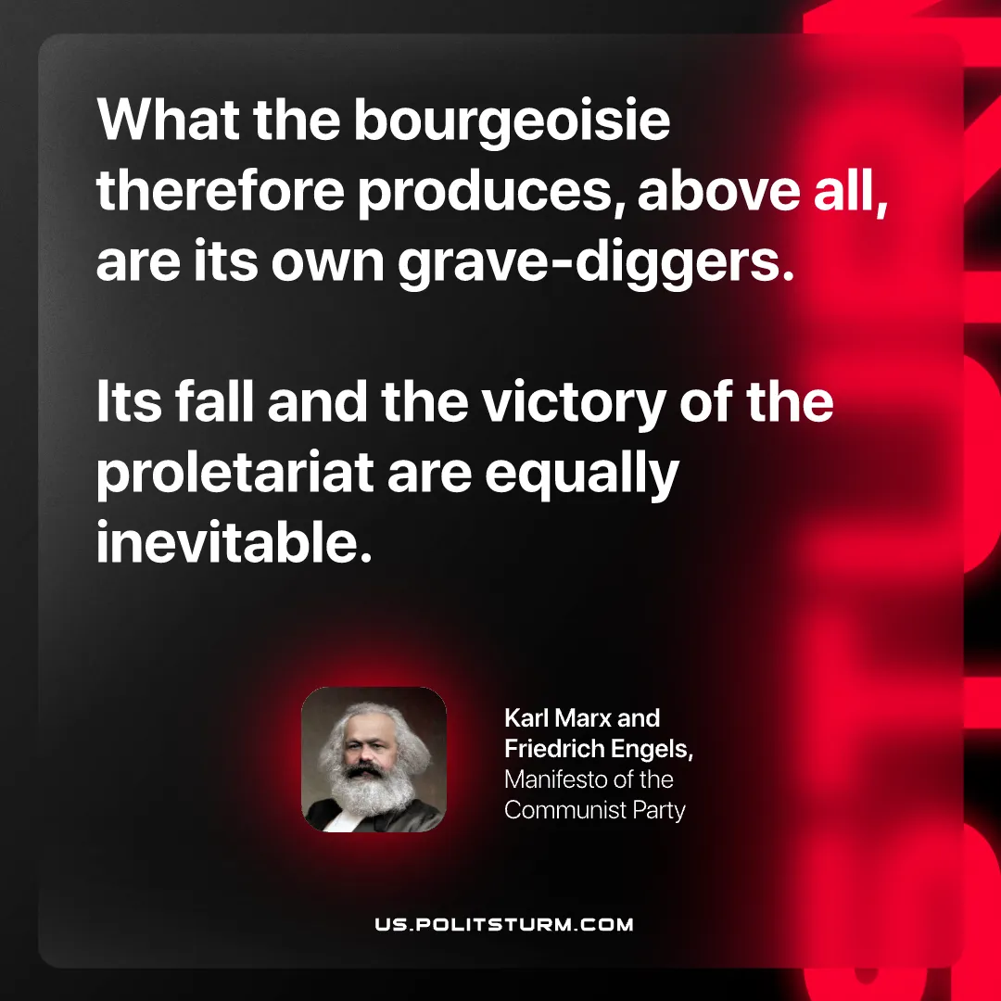

Original article
2026-08-09

What the bourgeoisie therefore produces, above all, are its own grave-diggers. Its fall and the victory of the proletariat are equally inevitable.
Karl Marx and Friedrich Engels, Manifesto of the Communist Party

Original article

