Marx on the First Birthright of Capital
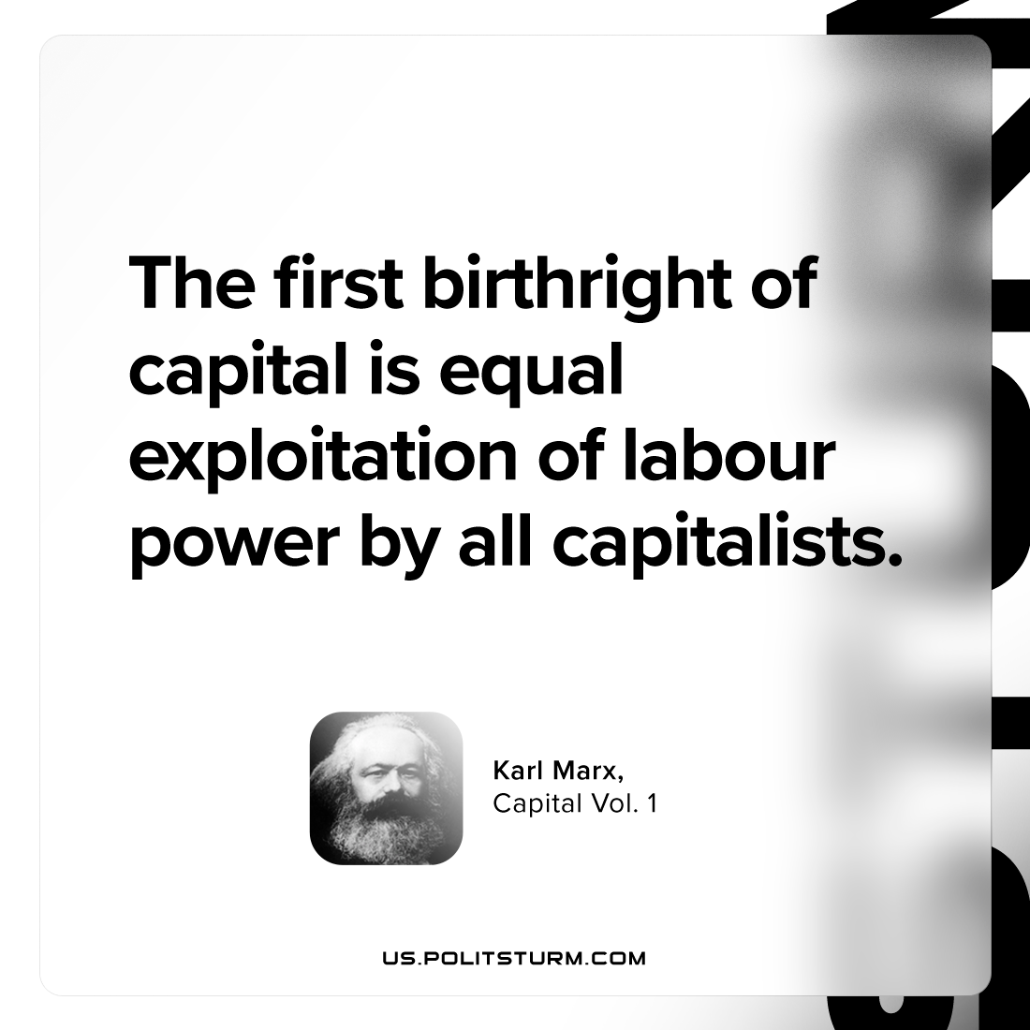

Original article
2023-12-10

"The first birthright of capital is equal exploitation of labour-power by all capitalists."
Karl Marx, Capital Vol. 1

Original article

