Marx on the Dictatorship of the Proletariat
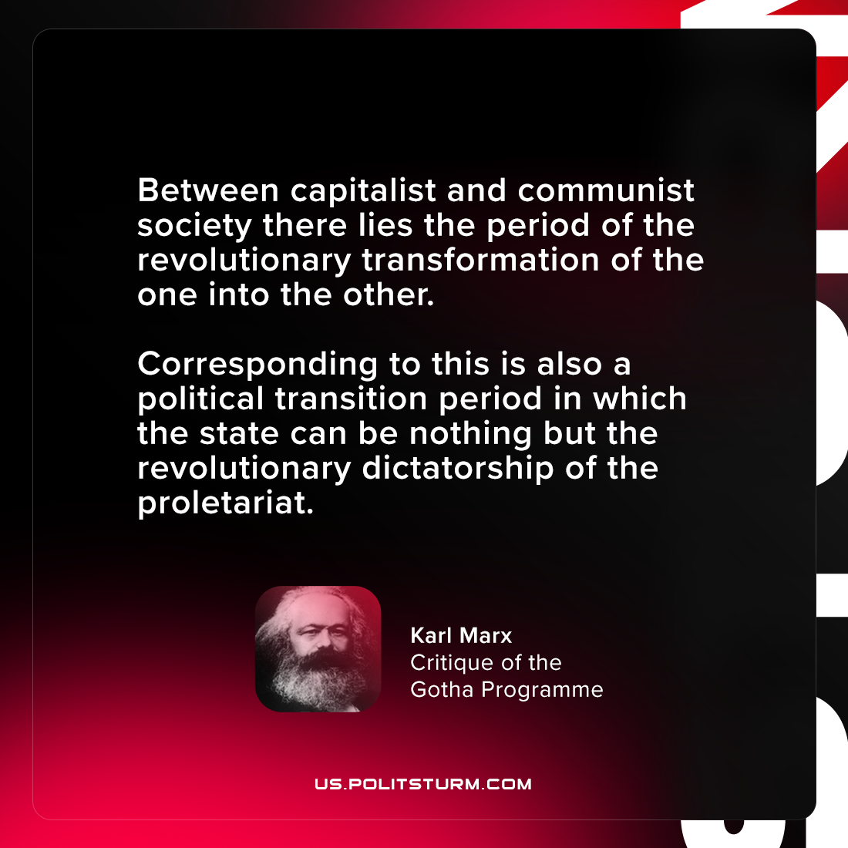

Original article
2021-08-11

Between capitalist and communist society there lies the period of the revolutionary transformation of the one into the other. Corresponding to this is also a political transition period in which the state can be nothing but the revolutionary dictatorship of the proletariat.

Karl Marx, “Critique of the Gotha Programme”

Original article

