Marx on the Determination of What is a Working-Day
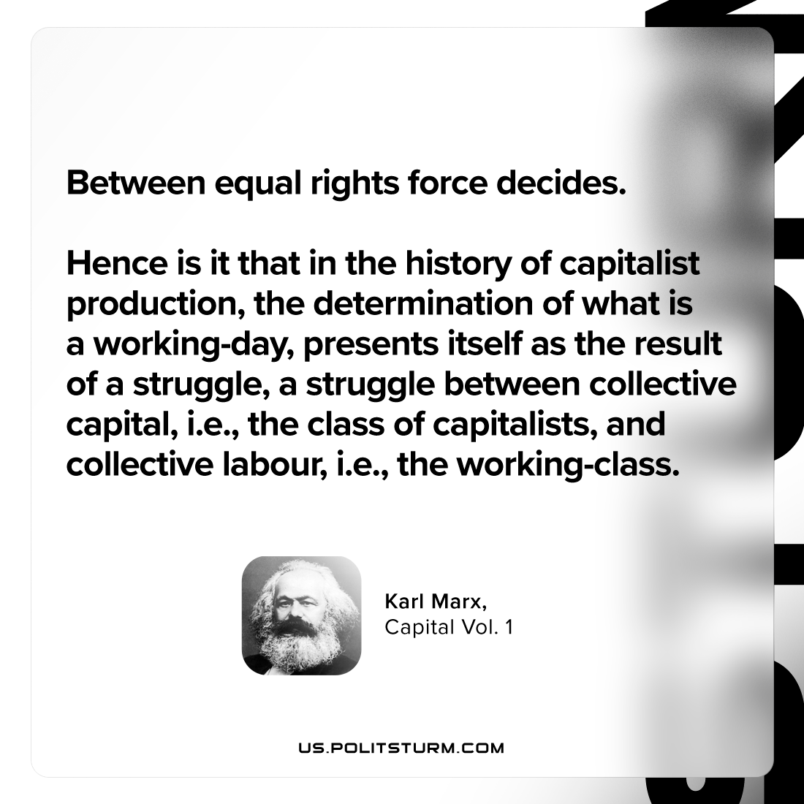

Original article
2023-11-26

"Between equal rights force decides. Hence is it that in the history of capitalist production, the determination of what is a working-day, presents itself as the result of a struggle, a struggle between collective capital, i.e., the class of capitalists, and collective labour, i.e., the working-class."
Karl Marx, Capital Vol. 1

Original article

