Marx on the Communist Society
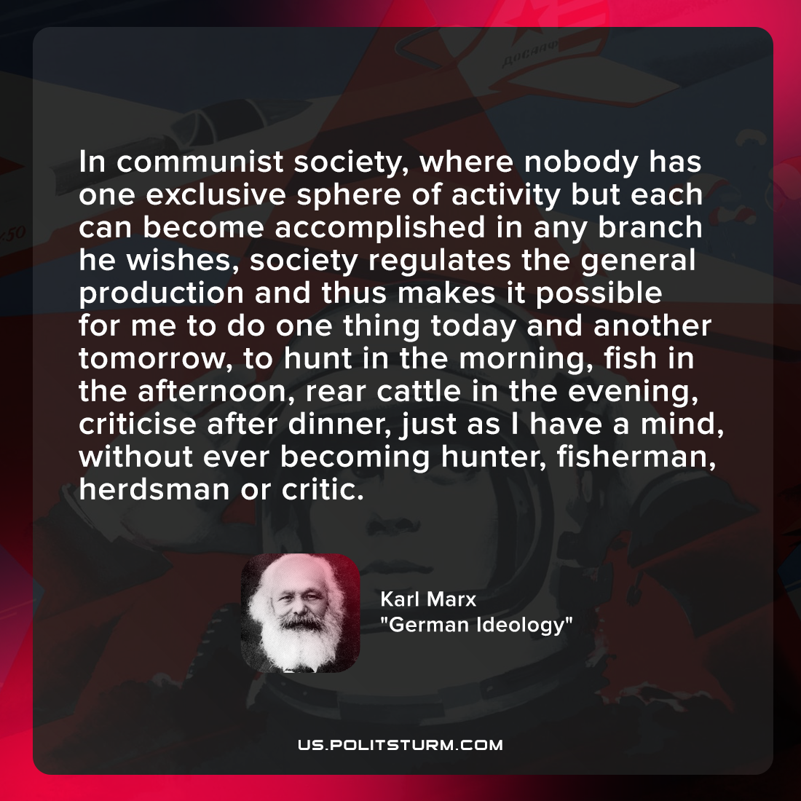

Original article
2021-12-08

In communist society, where nobody has one exclusive sphere of activity but each can become accomplished in any branch he wishes, society regulates the general production and thus makes it possible for me to do one thing today and another tomorrow, to hunt in the morning, fish in the afternoon, rear cattle in the evening, criticise after dinner, just as I have a mind, without ever becoming hunter, fisherman, herdsman or critic.

Karl Marx, “German Ideology”

Original article

