Marx on the Capitalist's Appeals to 'Nature' and History
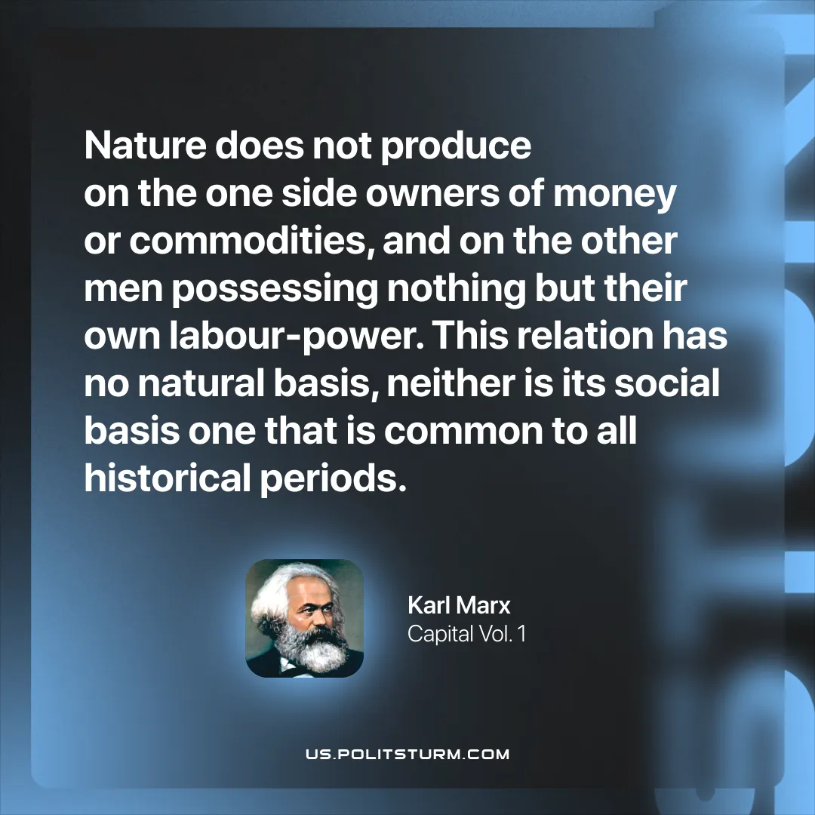

Original article
2026-03-31

“Nature does not produce on the one side owners of money or commodities, and on the other men possessing nothing but their own labour-power. This relation has no natural basis, neither is its social basis one that is common to all historical periods.”
Karl Marx, Capital Vol. 1

Original article

