Marx on Surplus Value
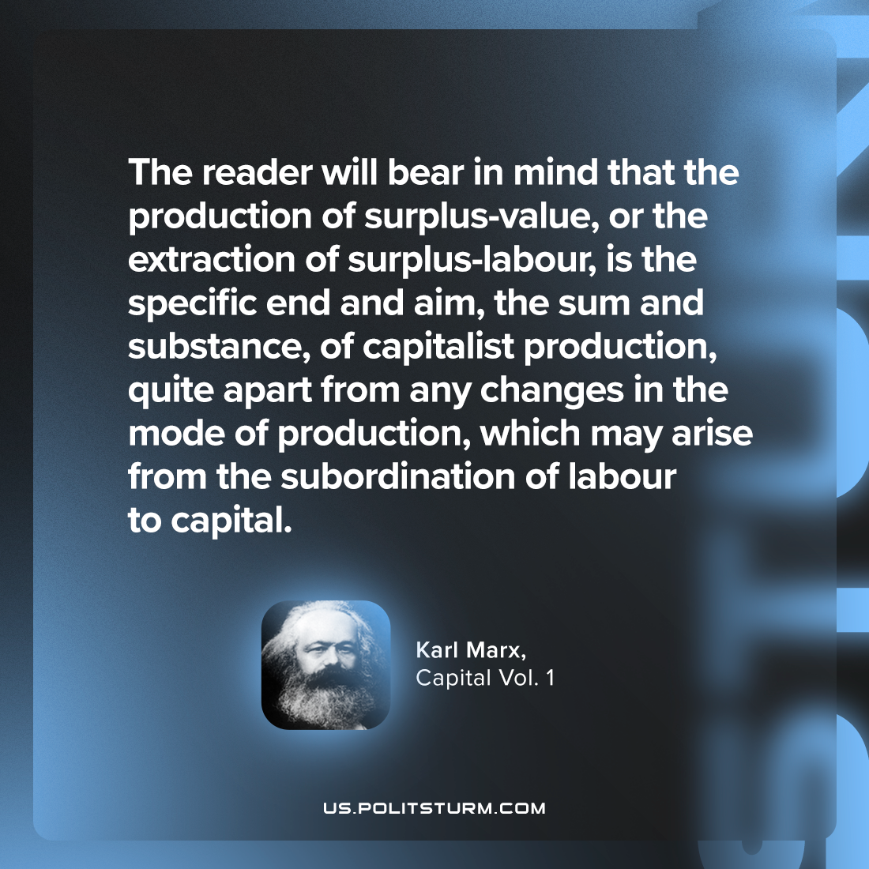

Original article
2024-02-04

"The reader will bear in mind that the production of surplus-value, or the extraction of surplus-labour, is the specific end and aim, the sum and substance, of capitalist production, quite apart from any changes in the mode of production, which may arise from the subordination of labour to capital."
Karl Marx, Capital Vol. 1

Original article

