Marx on Socialised Labour
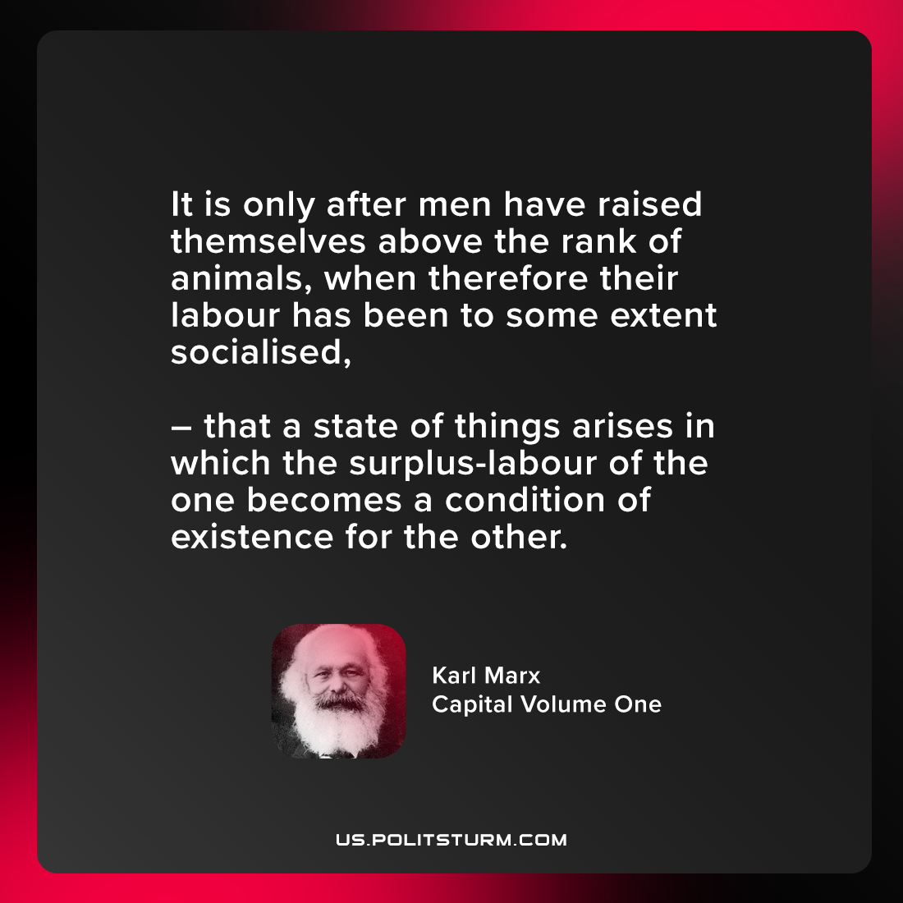

Original article
2021-08-07

It is only after men have raised themselves above the rank of animals, when therefore their labour has been to some extent socialised, that a state of things arises in which the surplus-labour of the one becomes a condition of existence for the other.

Karl Marx, “Capital Volume One: Part 5”

Original article

