Marx on Social Consciousness
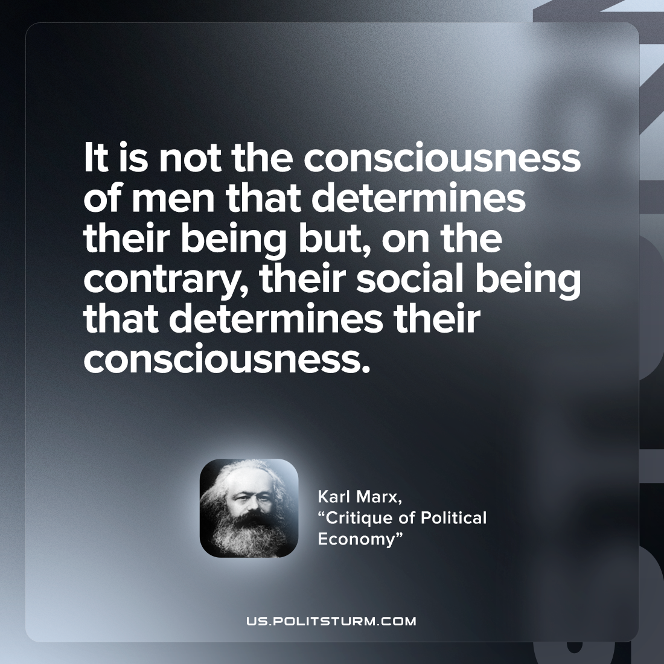

Original article
2022-11-26

It is not the consciousness of men that determines their being but, on the contrary, their social being that determines their consciousness.
Karl Marx, “Critique of Political Economy”

Original article

