Marx on Right to Work under Capitalism
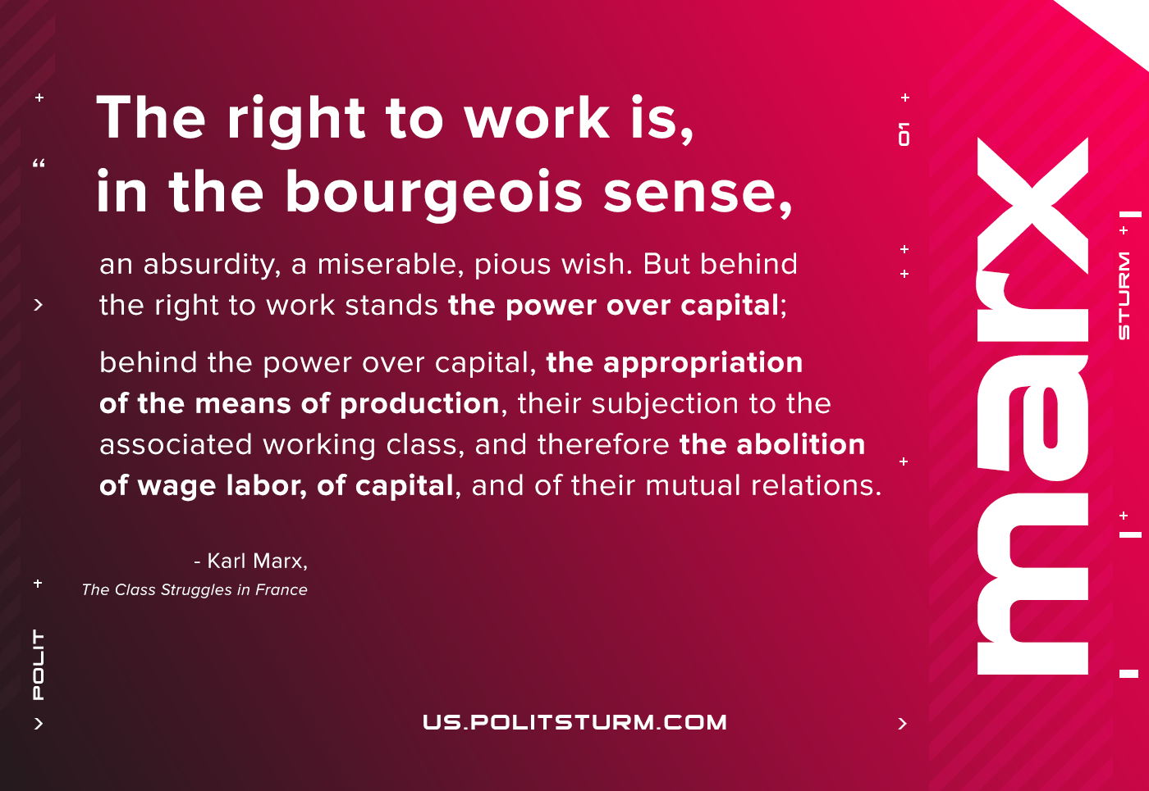

Original article
2021-02-08

The right to work is, in the bourgeois sense, an absurdity, a miserable, pious wish. But behind the right to work stands the power over capital; behind the power over capital, the appropriation of the means of production, their subjection to the associated working class, and therefore the abolition of wage labor, of capital, and of their mutual relations.
Karl Marx, The Class Struggles in France

Original article

