Marx on Revolutions and Crises
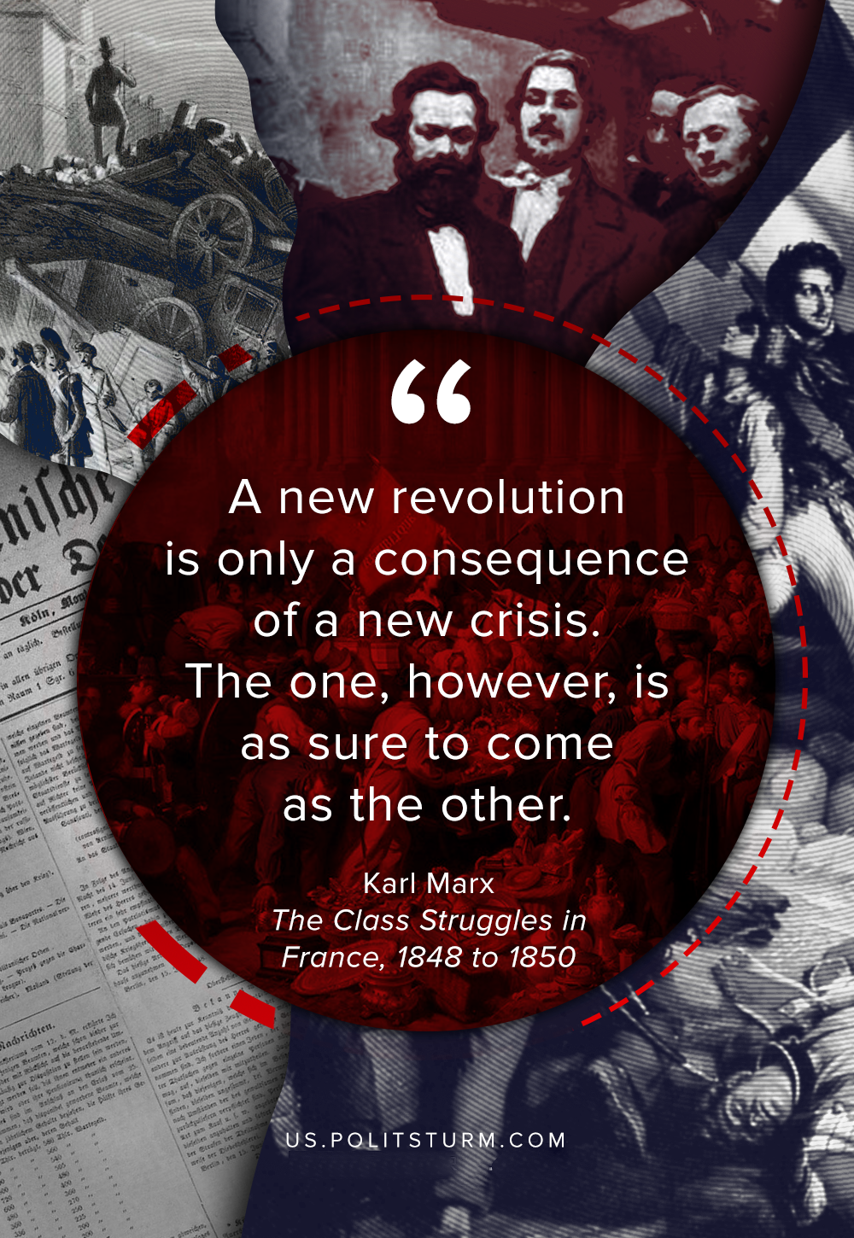

Original article
2020-03-10

A new revolution is only a consequence of a new crisis. The one, however, is as sure to come as the other.
Karl Marx, The Class Struggles in France, 1848 to 1850

Original article

