Marx on Revolutionary Practice
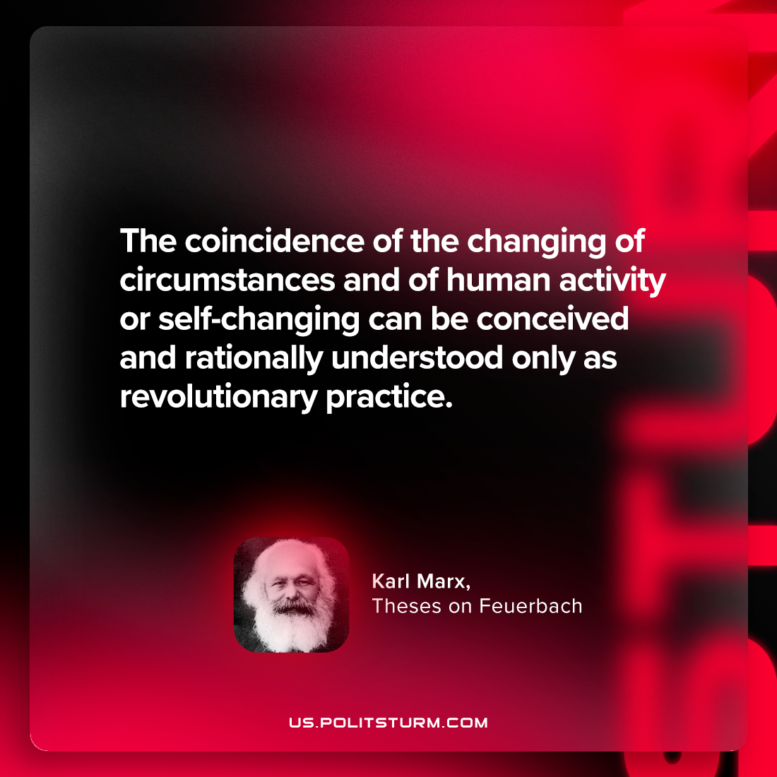

Original article
2024-05-16

"The coincidence of the changing of circumstances and of human activity or self-changing can be conceived and rationally understood only as revolutionary practice."
Karl Marx, Theses on Feuerbach

Original article

