Marx on Religion
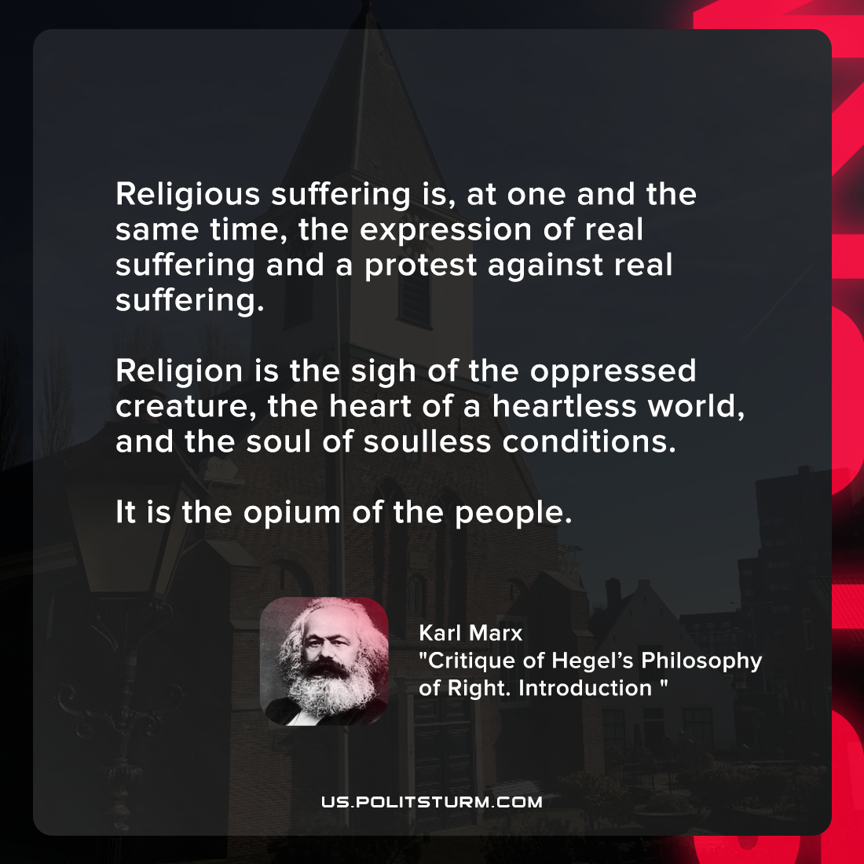

Original article
2021-11-11

Religious suffering is, at one and the same time, the expression of real suffering and a protest against real suffering. Religion is the sigh of the oppressed creature, the heart of a heartless world, and the soul of soulless conditions. It is the opium of the people.

Karl Marx, “Critique of Hegel’s Philosophy of Right. Introduction”

Original article

