Marx on Recklessness of Capital
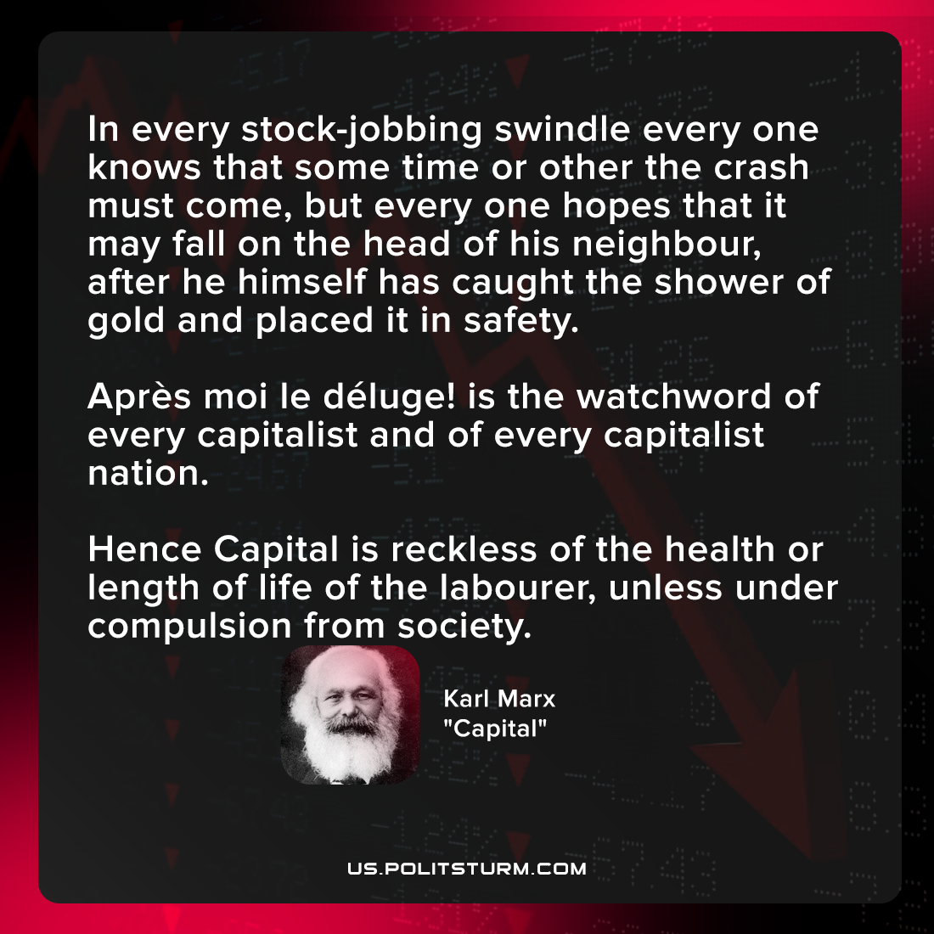

Original article
2022-01-01

In every stock-jobbing swindle every one knows that some time or other the crash must come, but every one hopes that it may fall on the head of his neighbour, after he himself has caught the shower of gold and placed it in safety. Après moi le déluge! is the watchword of every capitalist and of every capitalist nation. Hence Capital is reckless of the health or length of life of the labourer, unless under compulsion from society.

Karl Marx, “Capital”

Original article

