Marx on Private Property
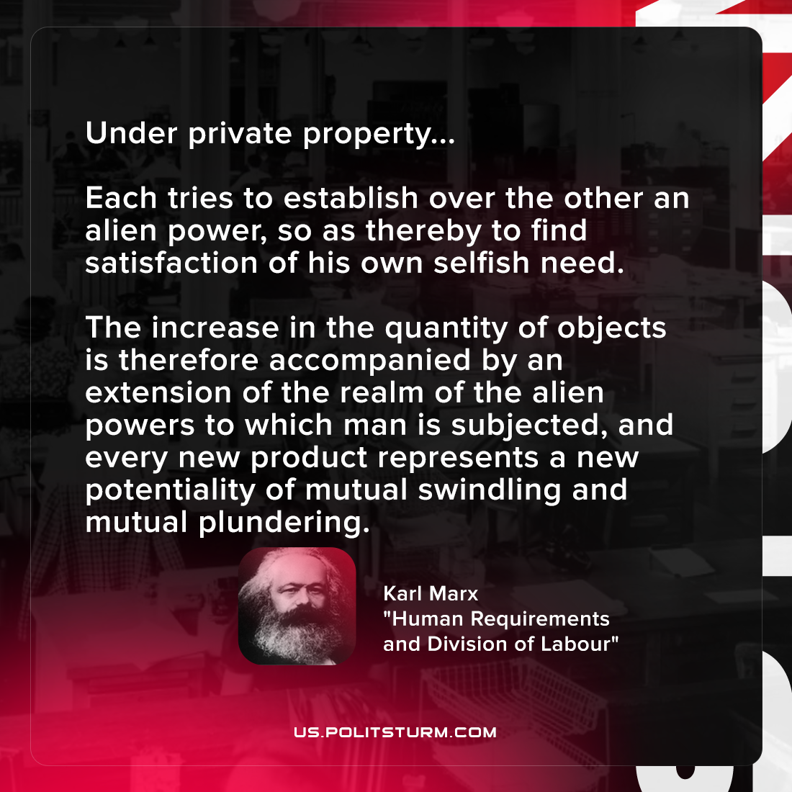

Original article
2021-10-26

Under private property … Each tries to establish over the other an alien power, so as thereby to find satisfaction of his own selfish need. The increase in the quantity of objects is therefore accompanied by an extension of the realm of the alien powers to which man is subjected, and every new product represents a new potentiality of mutual swindling and mutual plundering.

Karl Marx, “Human Requirements and Division of Labour”

Original article

