Marx on Materialist Doctrine and Education
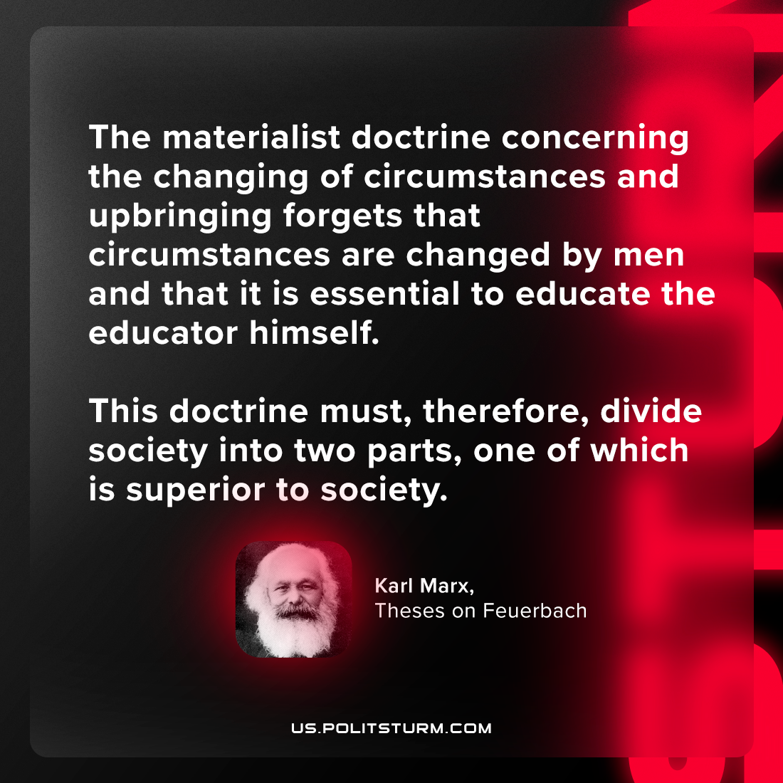

Original article
2024-06-30

"The materialist doctrine concerning the changing of circumstances and upbringing forgets that circumstances are changed by men and that it is essential to educate the educator himself. This doctrine must, therefore, divide society into two parts, one of which is superior to society."
Karl Marx, Theses on Feuerbach

Original article

