Marx on Increasing Labor Productivity and Reducing the Cost of Labor
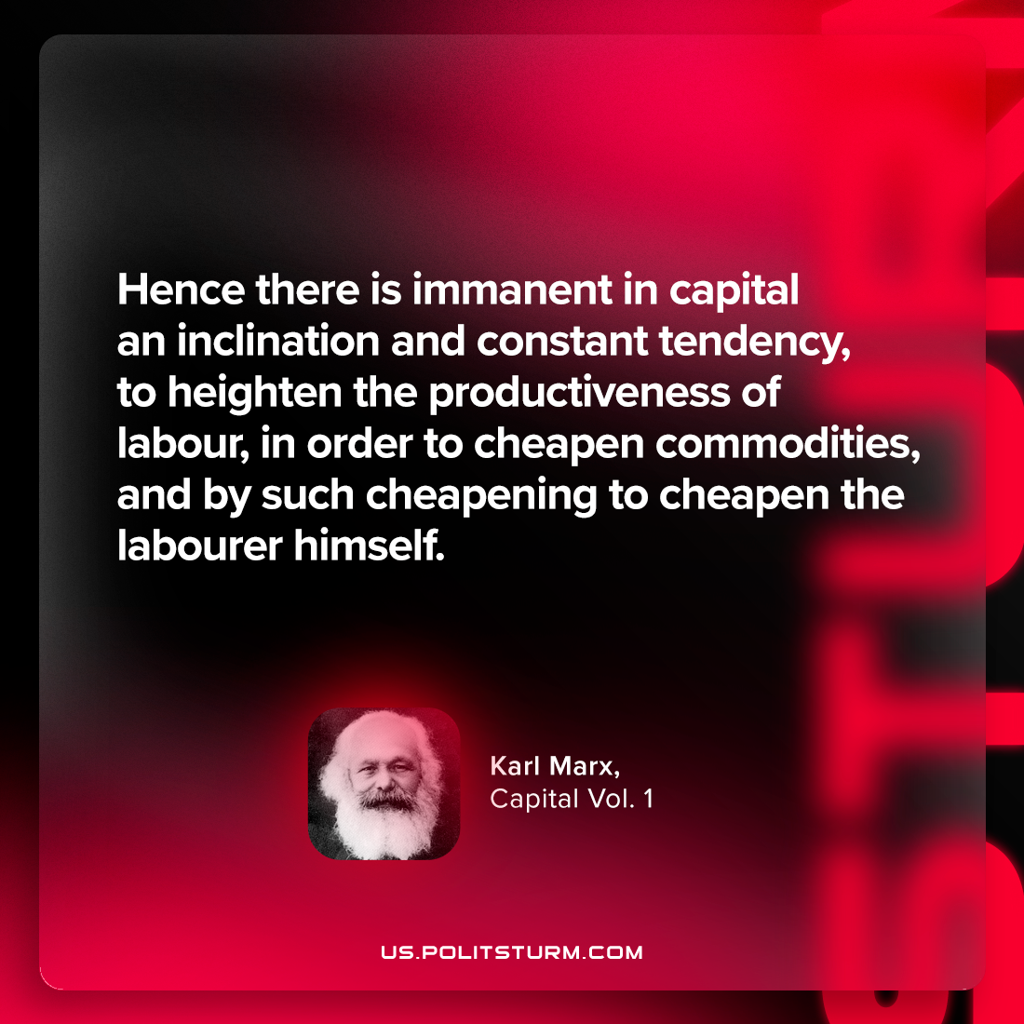

Original article
2024-01-21

"Hence there is immanent in capital an inclination and constant tendency, to heighten the productiveness of labour, in order to cheapen commodities, and by such cheapening to cheapen the labourer himself."
Karl Marx, Capital Vol. 1

Original article

