Marx on how 'Free Labor' Under Capitalism is not Free
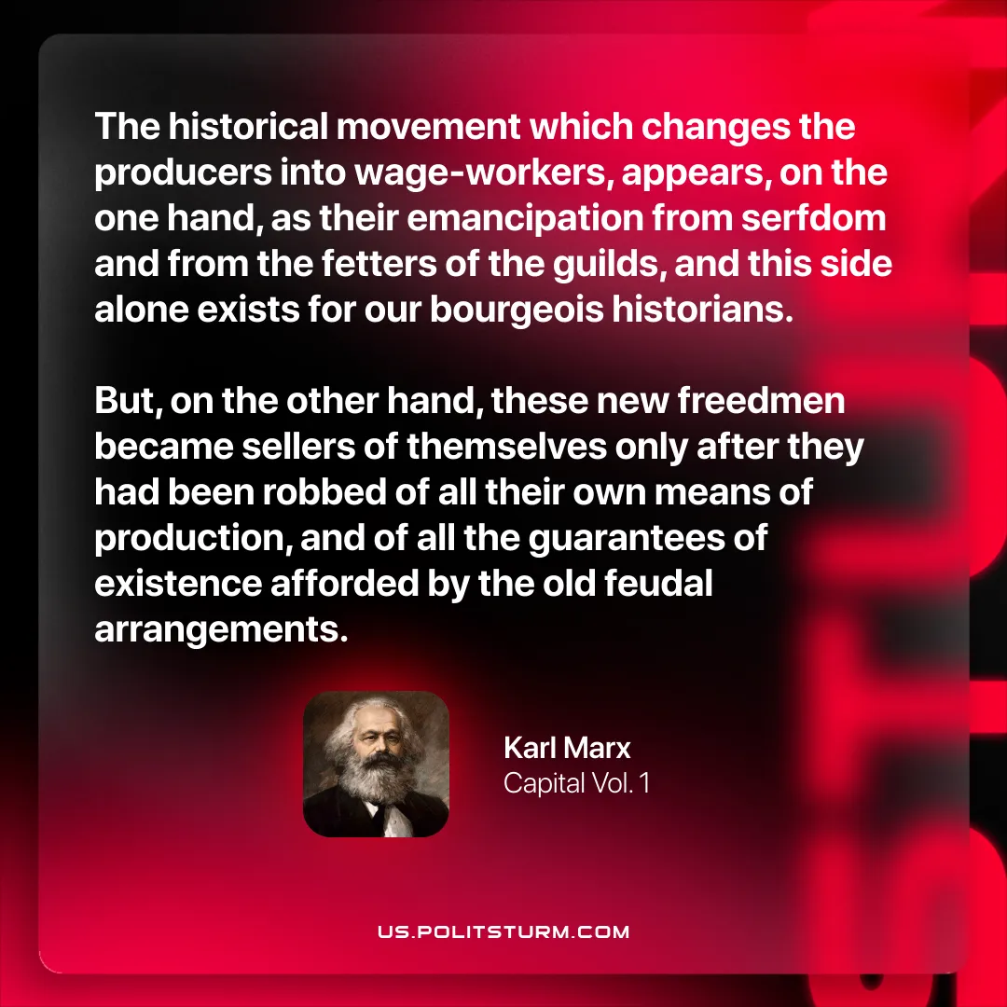

Original article
2026-03-29

“The historical movement which changes the producers into wage-workers, appears, on the one hand, as their emancipation from serfdom and from the fetters of the guilds, and this side alone exists for our bourgeois historians. But, on the other hand, these new freedmen became sellers of themselves only after they had been robbed of all their own means of production, and of all the guarantees of existence afforded by the old feudal arrangements.”
Karl Marx, Capital Vol. 1

Original article

