Marx on how Capitalism Ensnares the Worker
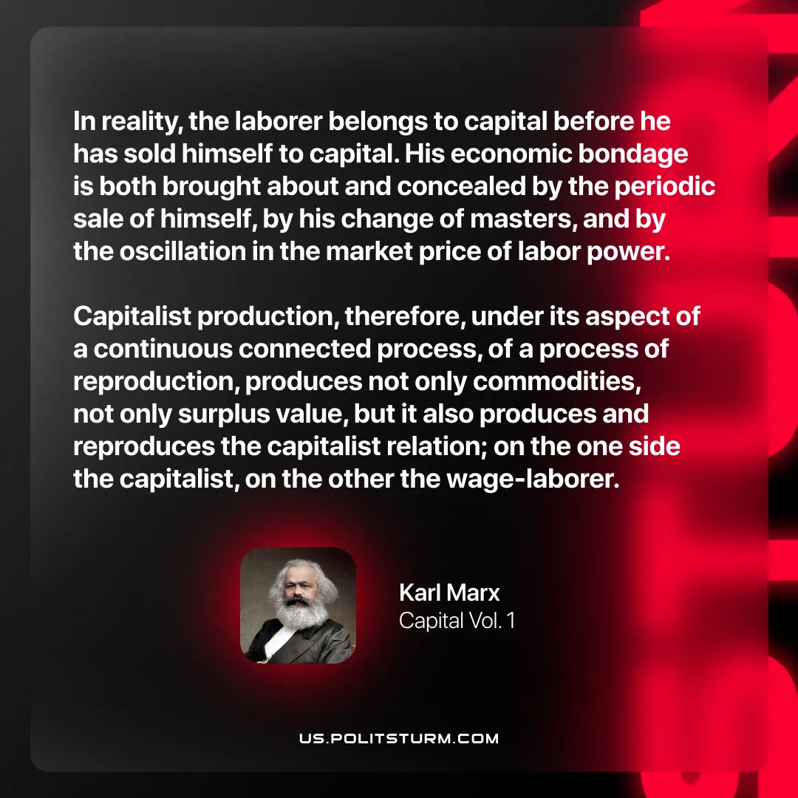

Original article
2026-03-28
1 min read

“In reality, the laborer belongs to capital before he has sold himself to capital. His economic bondage is both brought about and concealed by the periodic sale of himself, by his change of masters, and by the oscillation in the market price of labor power. Capitalist production, therefore, under its aspect of a continuous connected process, of a process of reproduction, produces not only commodities, not only surplus value, but it also produces and reproduces the capitalist relation; on the one side the capitalist, on the other the wage-laborer.”
Karl Marx, Capital Vol. 1

Original article

