Marx on Estrangement from Product of Labor
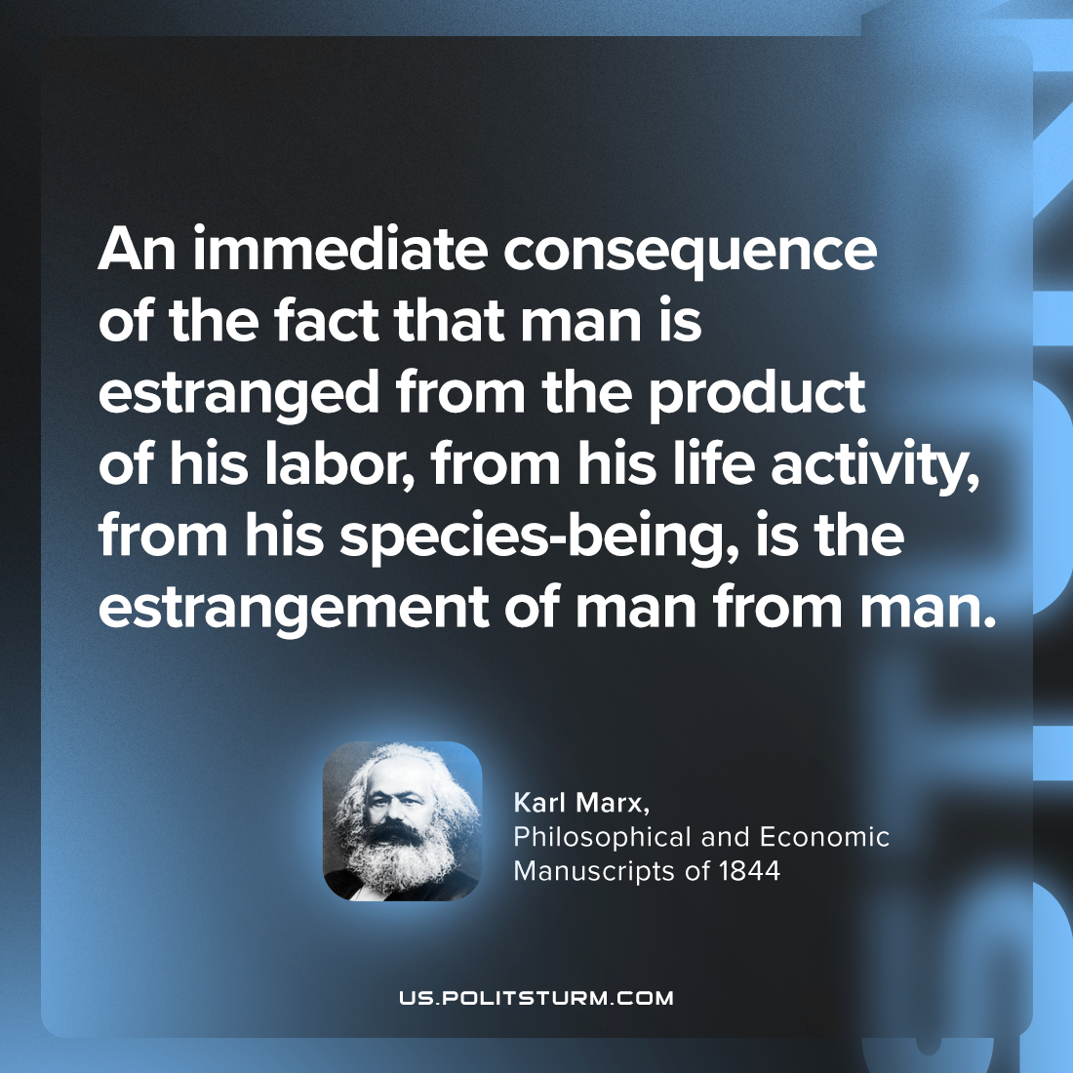

Original article
2024-04-24

“An immediate consequence of the fact that man is estranged from the product of his labor, from his life activity, from his species-being, is the estrangement of man from man.”
Karl Marx, Philosophical and Economic Manuscripts of 1844

Original article

