Marx on Emancipation and Slavery
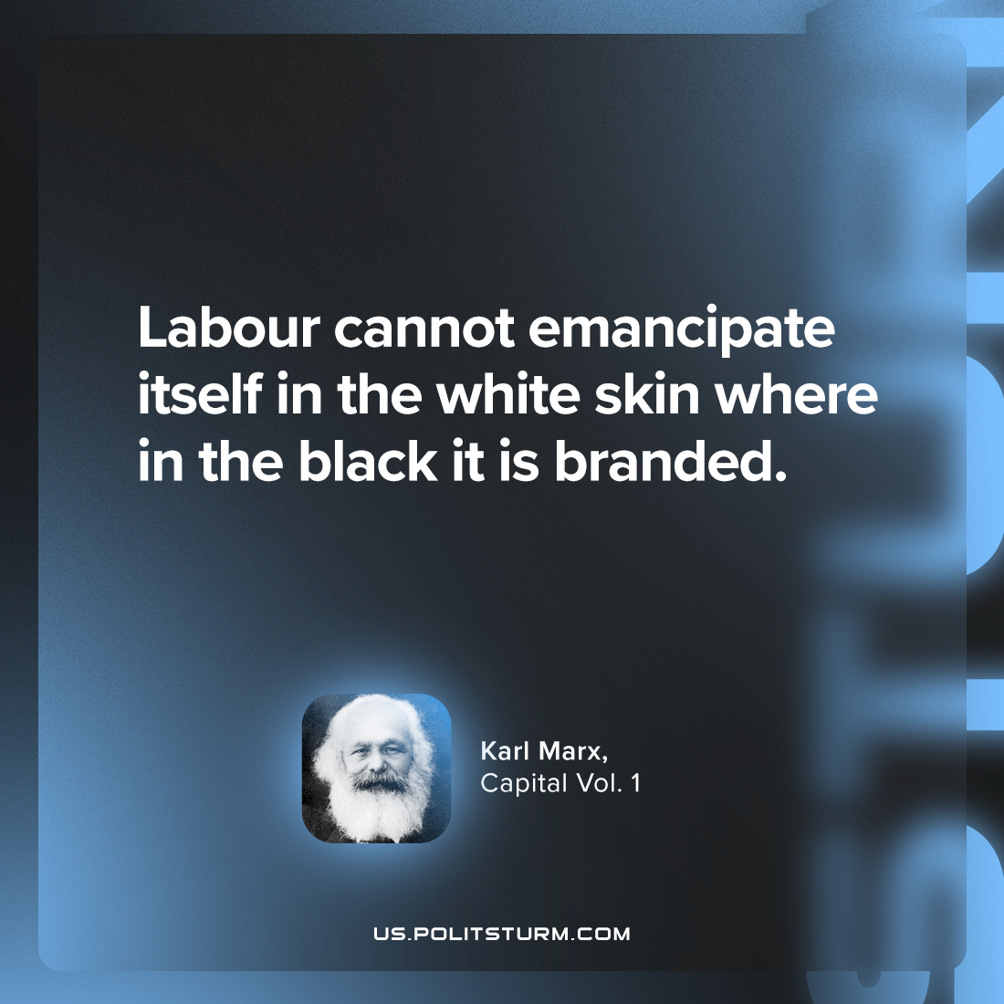

Original article
2023-12-09

"Labour cannot emancipate itself in the white skin where in the black it is branded."
Karl Marx, Capital Vol. 1

Original article

