Marx on Consciousness
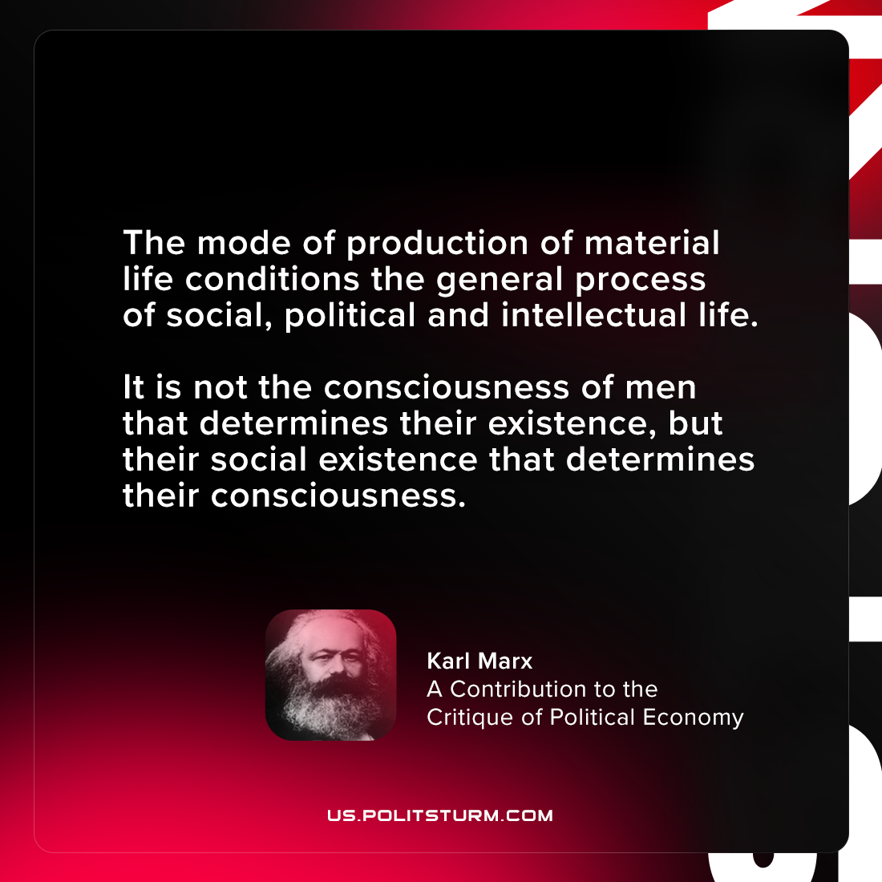

Original article
2021-07-30

The mode of production of material life conditions the general process of social, political and intellectual life. It is not the consciousness of men that determines their existence, but their social existence that determines their consciousness.
Karl Marx, “A Contribution to the Critique of Political Economy”

Original article

