Marx on Consciousness
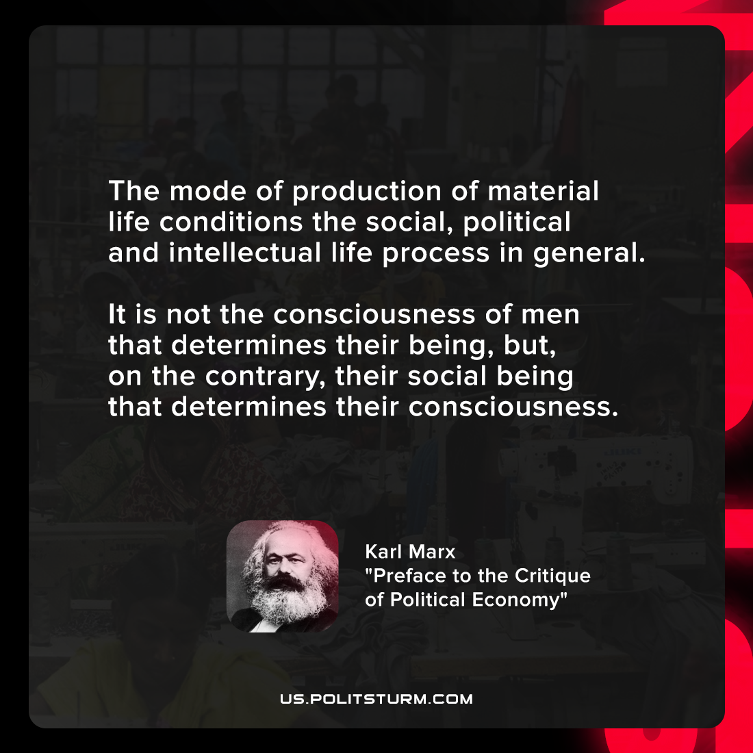

Original article
2021-11-17

The mode of production of material life conditions the social, political and intellectual life process in general. It is not the consciousness of men that determines their being, but, on the contrary, their social being that determines their consciousness.

Karl Marx, “Preface to the Critique of Political Economy”

Original article

