Marx on Communism
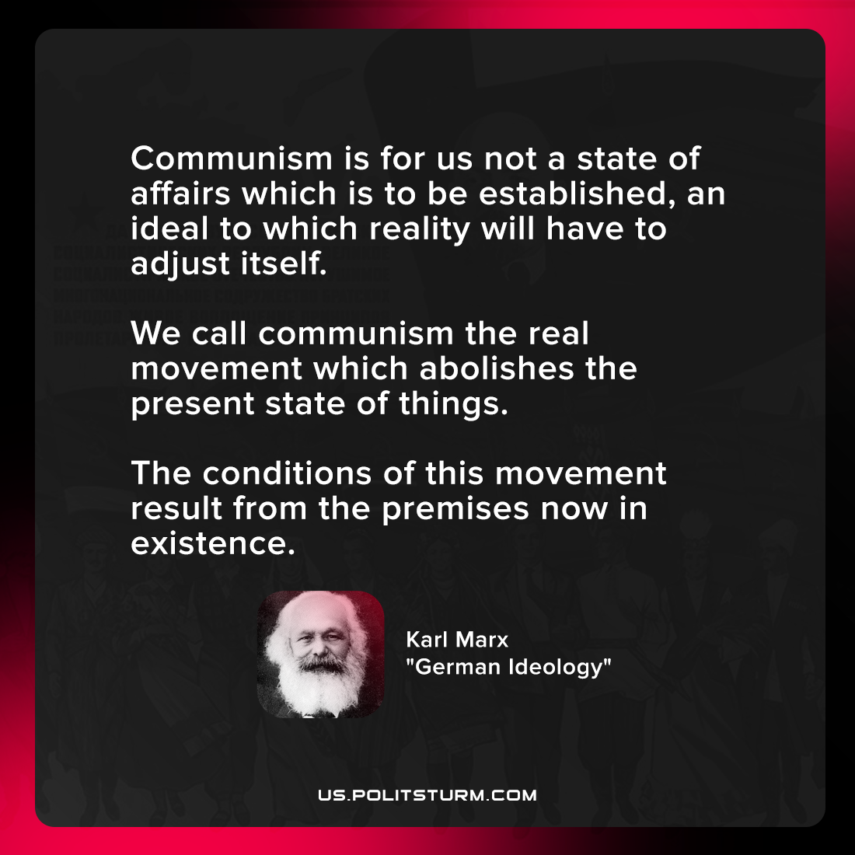

Original article
2021-11-11

Communism is for us not a state of affairs which is to be established, an ideal to which reality will have to adjust itself. We call communism the real movement which abolishes the present state of things. The conditions of this movement result from the premises now in existence.

Karl Marx, “German Ideology”

Original article

