Marx on Capitalist Production
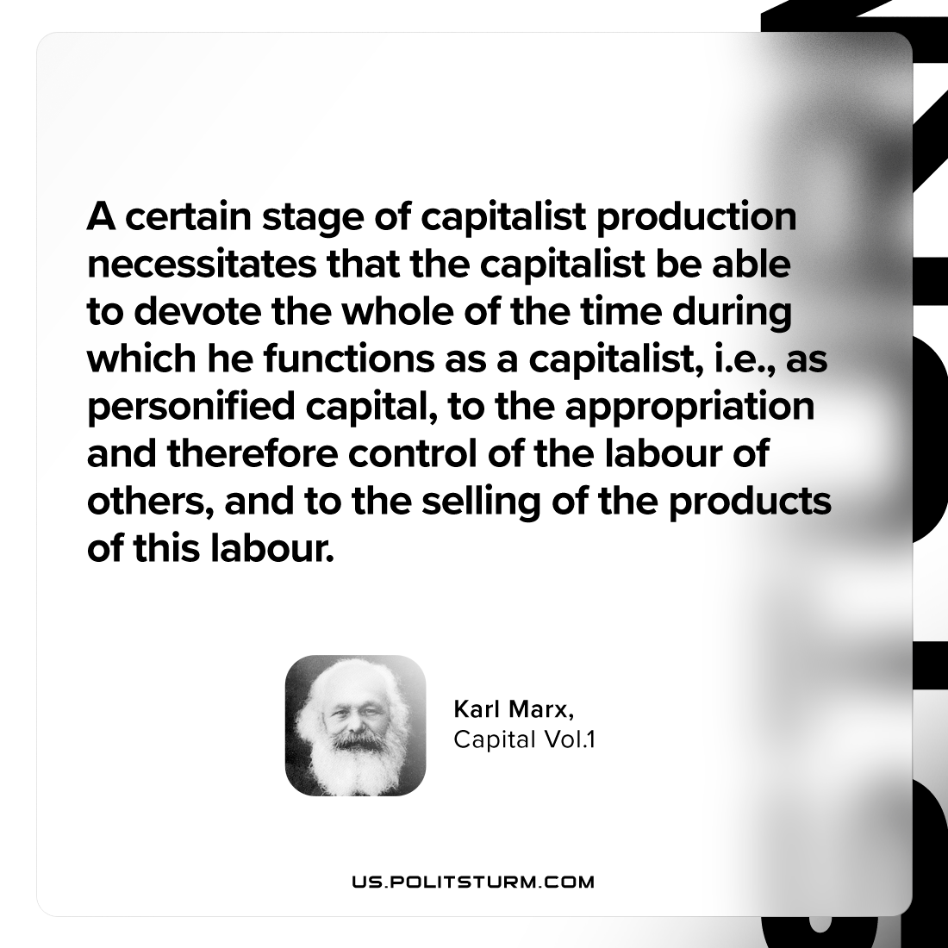

Original article
2024-04-25

“A certain stage of capitalist production necessitates that the capitalist be able to devote the whole of the time during which he functions as a capitalist, i.e., as personified capital, to the appropriation and therefore control of the labour of others, and to the selling of the products of this labour.”
Karl Marx, Capital Vol. 1

Original article

