Marx on Capital Cracking Down on Worker Resistance
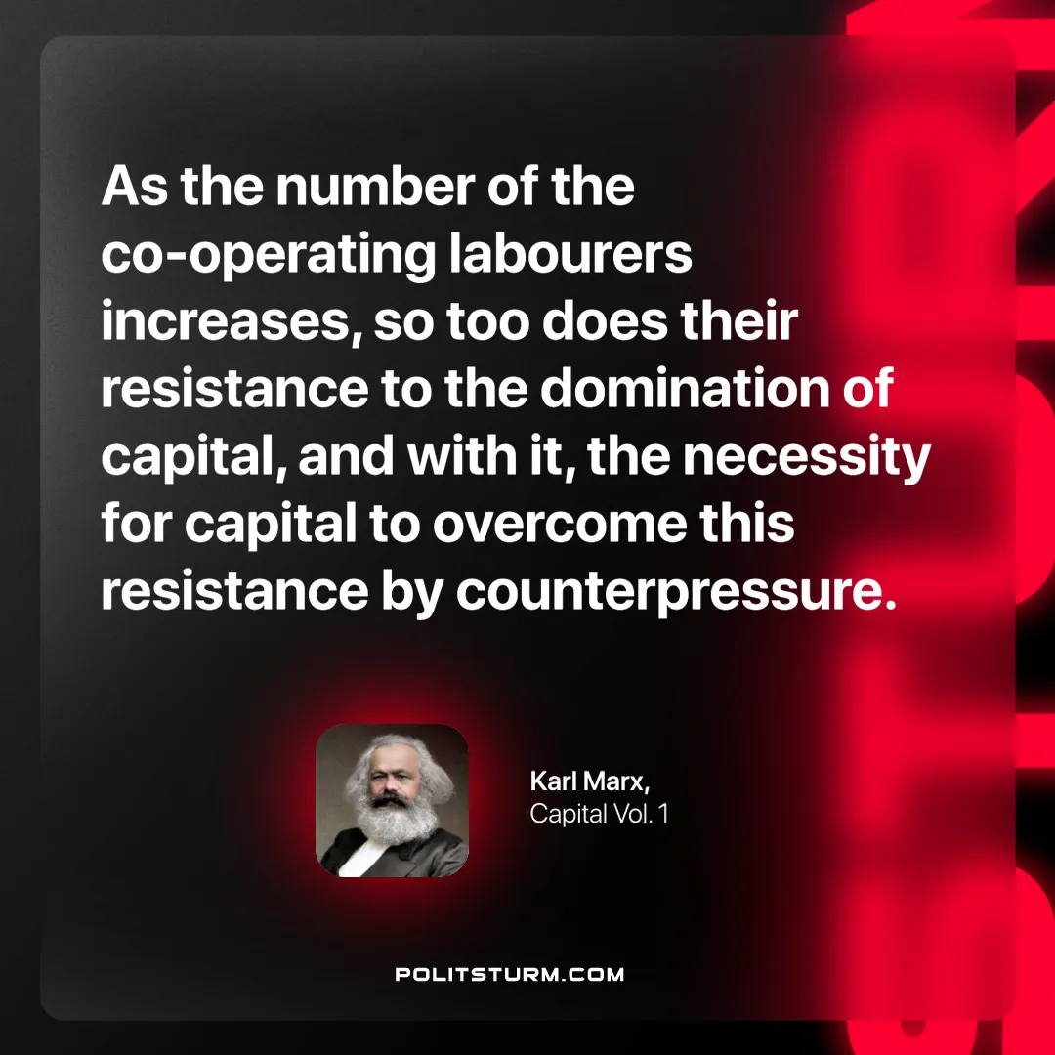

Original article
2025-01-09

“As the number of the co-operating labourers increases, so too does their resistance to the domination of capital, and with it, the necessity for capital to overcome this resistance by counterpressure.”
Karl Marx, Capital Vol. 1

Original article

