Marx on Capital and its Tendency
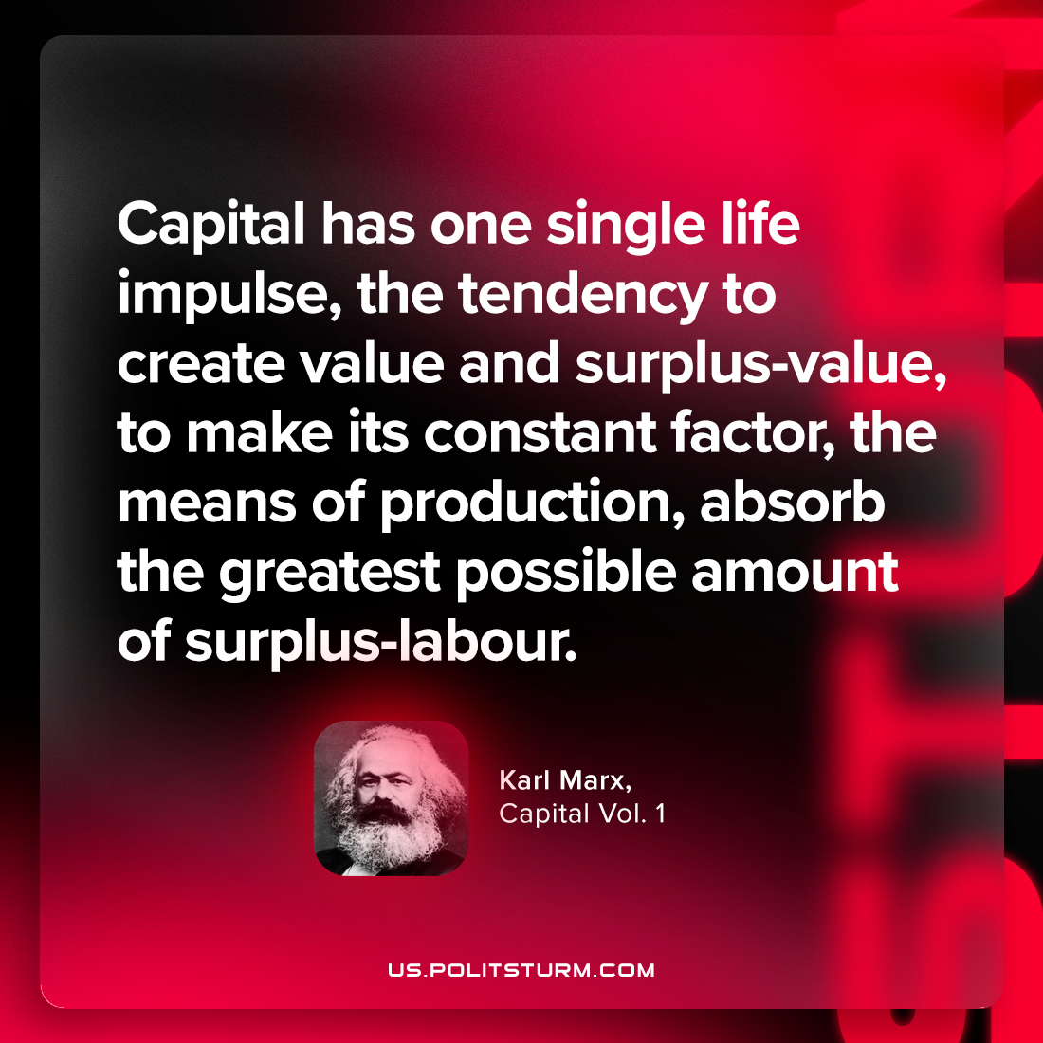

Original article
2023-10-31

"Capital has one single life impulse, the tendency to create value and surplus-value, to make its constant factor, the means of production, absorb the greatest possible amount of surplus-labour."
Karl Marx, Capital Vol. 1

Original article

