Marx on Alienating Labor
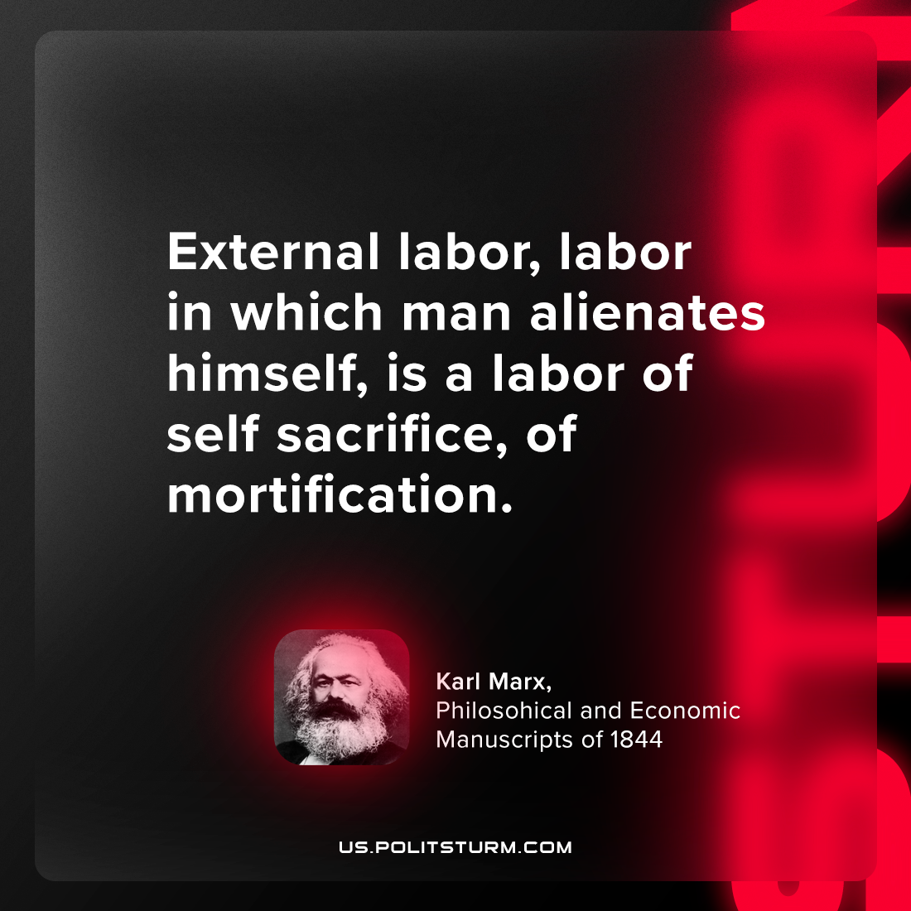

Original article
2024-05-26

"External labor, labor in which man alienates himself, is a labor of self-sacrifice, of mortification."
Karl Marx, Philosophical and Economic Manuscripts of 1844

Original article

