Marx on the Need to Test the Real State of Wages by Strikes
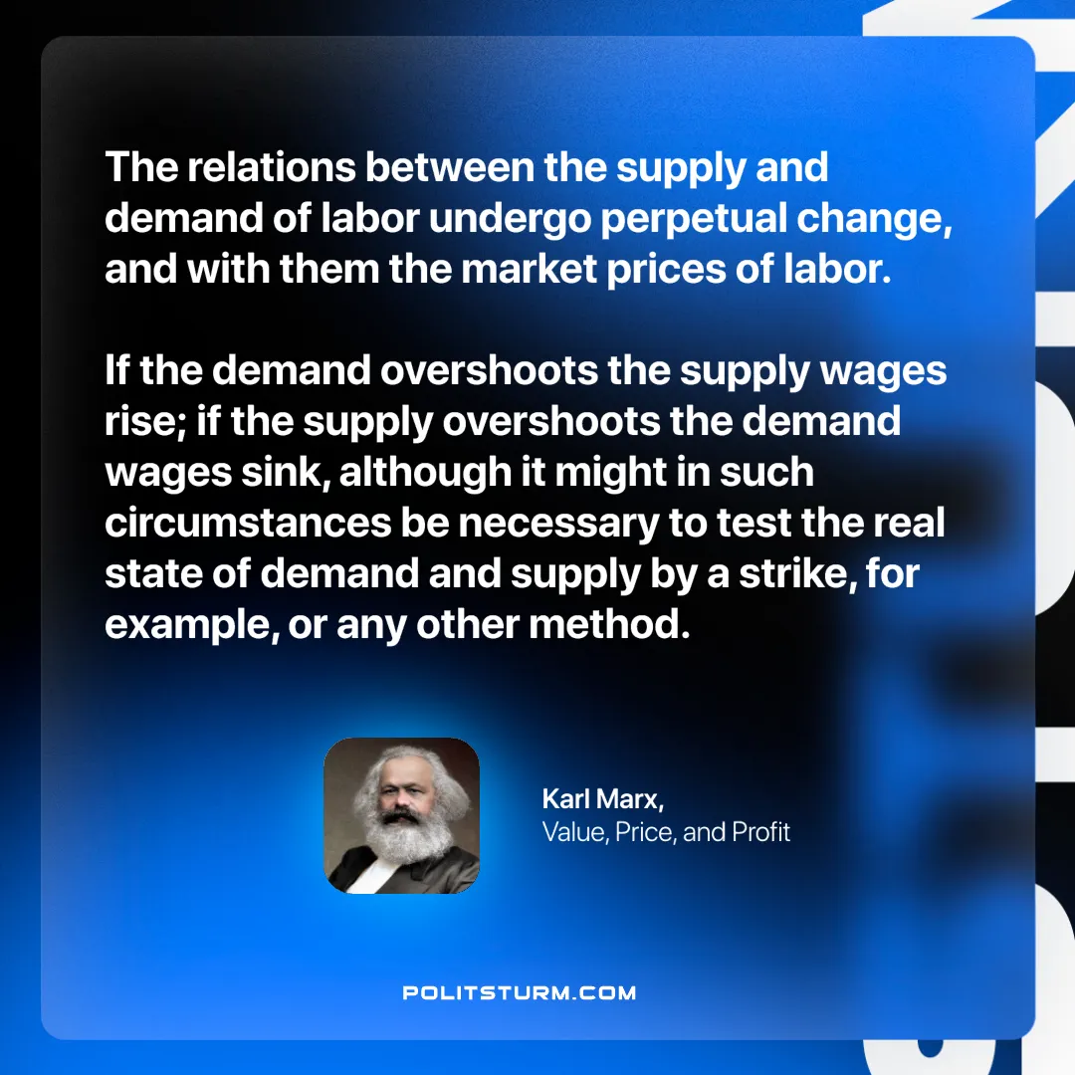

Original article
2025-02-13

“The relations between the supply and demand of labor undergo perpetual change, and with them the market prices of labor. If the demand overshoots the supply wages rise; if the supply overshoots the demand wages sink, although it might in such circumstances be necessary to test the real state of demand and supply by a strike, for example, or any other method.”
Karl Marx, Value, Price, and Profit

Original article

