Marx and Engels on the Theory of the Communists
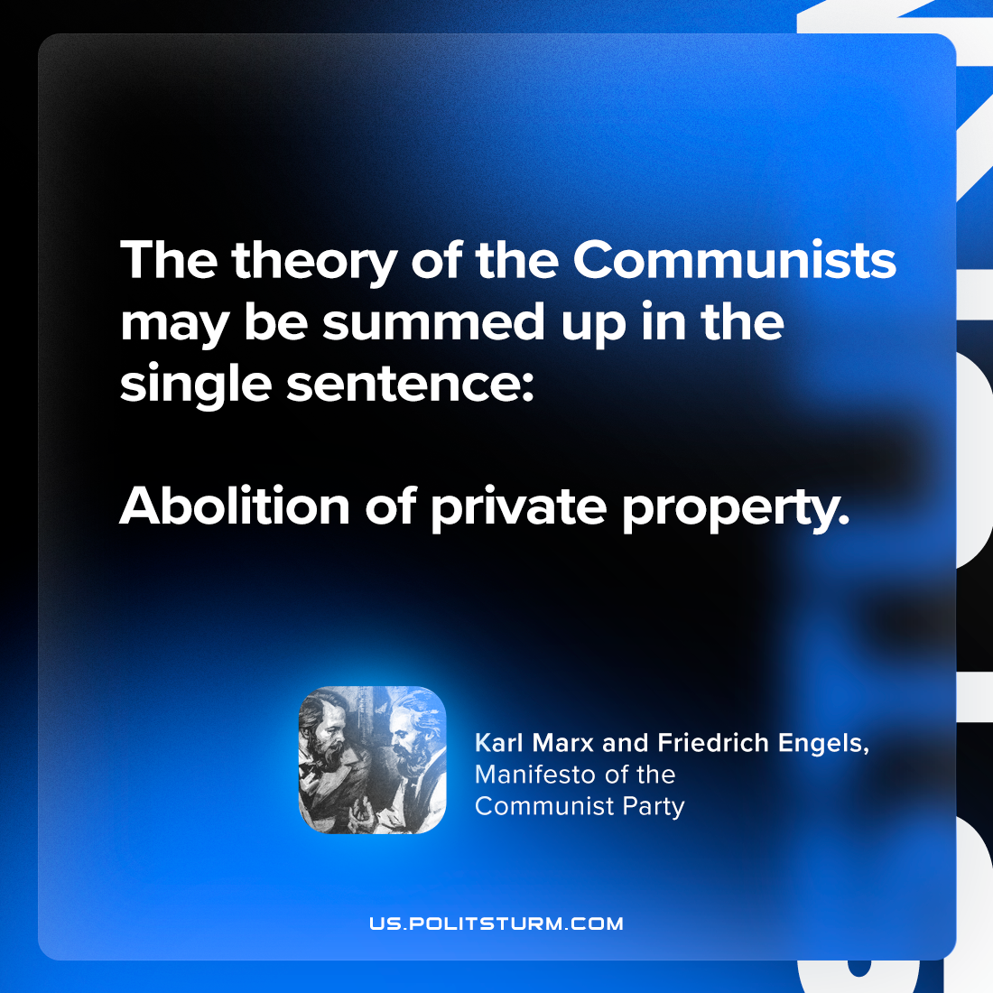

Original article
2023-12-02

"The theory of the Communists may be summed up in the single sentence: Abolition of private property."
Karl Marx and Friedrich Engels, Manifesto of the Communist Party

Original article

