Marx and Engels on the Proletariat as a Revolutionary Class
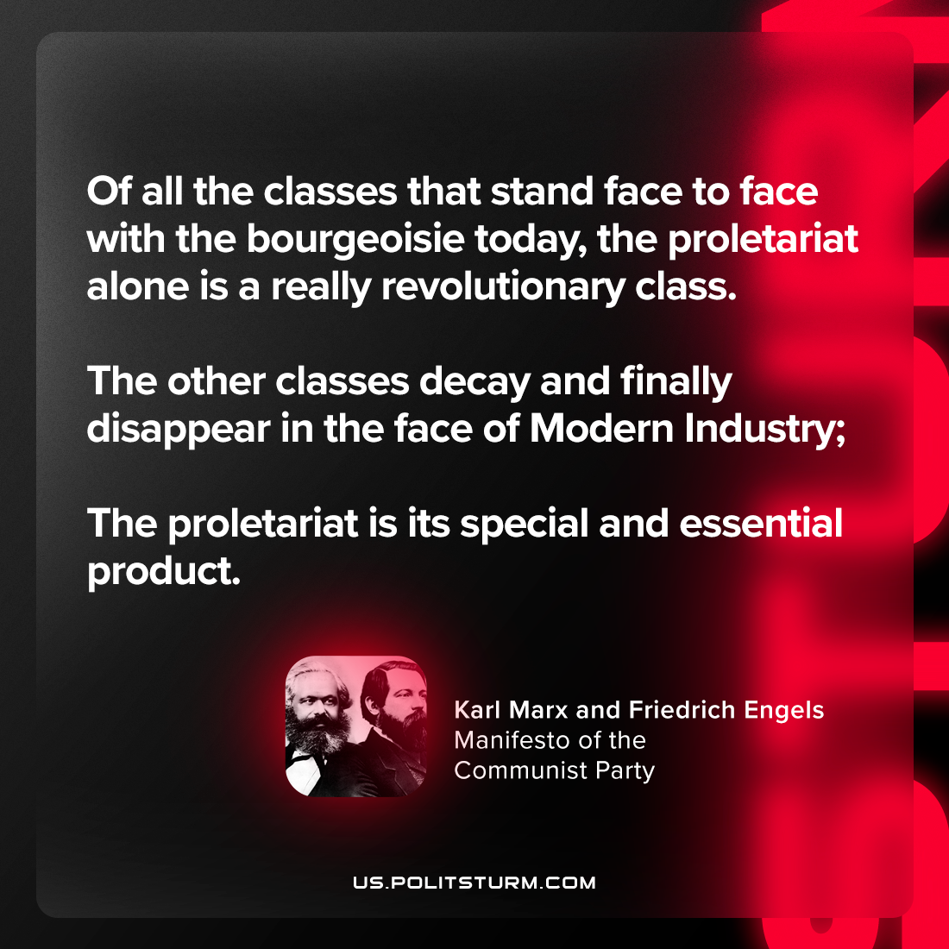

Original article
2024-02-01

"Of all the classes that stand face to face with the bourgeoisie today, the proletariat alone is a really revolutionary class. The other classes decay and finally disappear in the face of Modern Industry; the proletariat is its special and essential product."
Karl Marx and Friedrich Engels, Manifesto of the Communist Party

Original article

