Marx and Engels on the Proletarian Movement
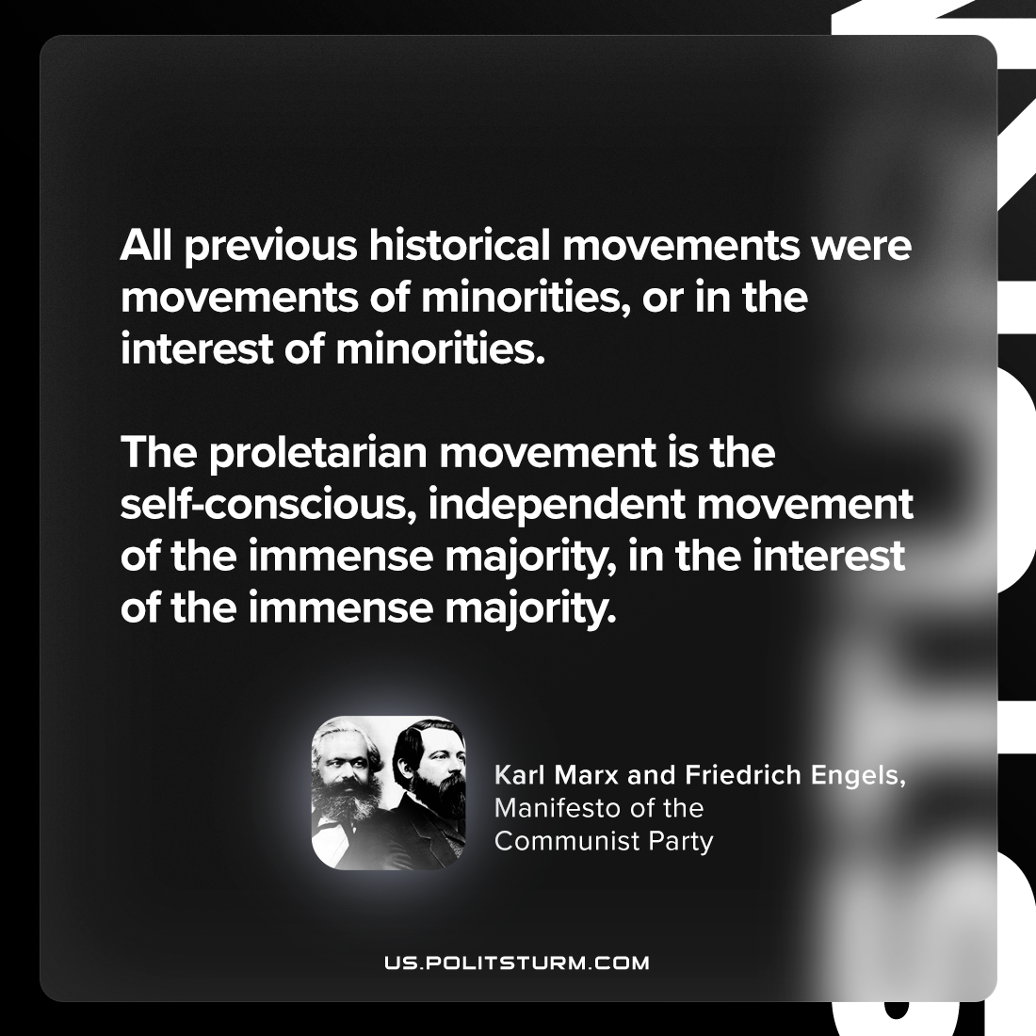

Original article
2023-11-30

"All previous historical movements were movements of minorities, or in the interest of minorities. The proletarian movement is the self-conscious, independent movement of the immense majority, in the interest of the immense majority."
Karl Marx and Friedrich Engels, Manifesto of the Communist Party

Original article

