Marx and Engels on the Progressive Power of the Proletariat
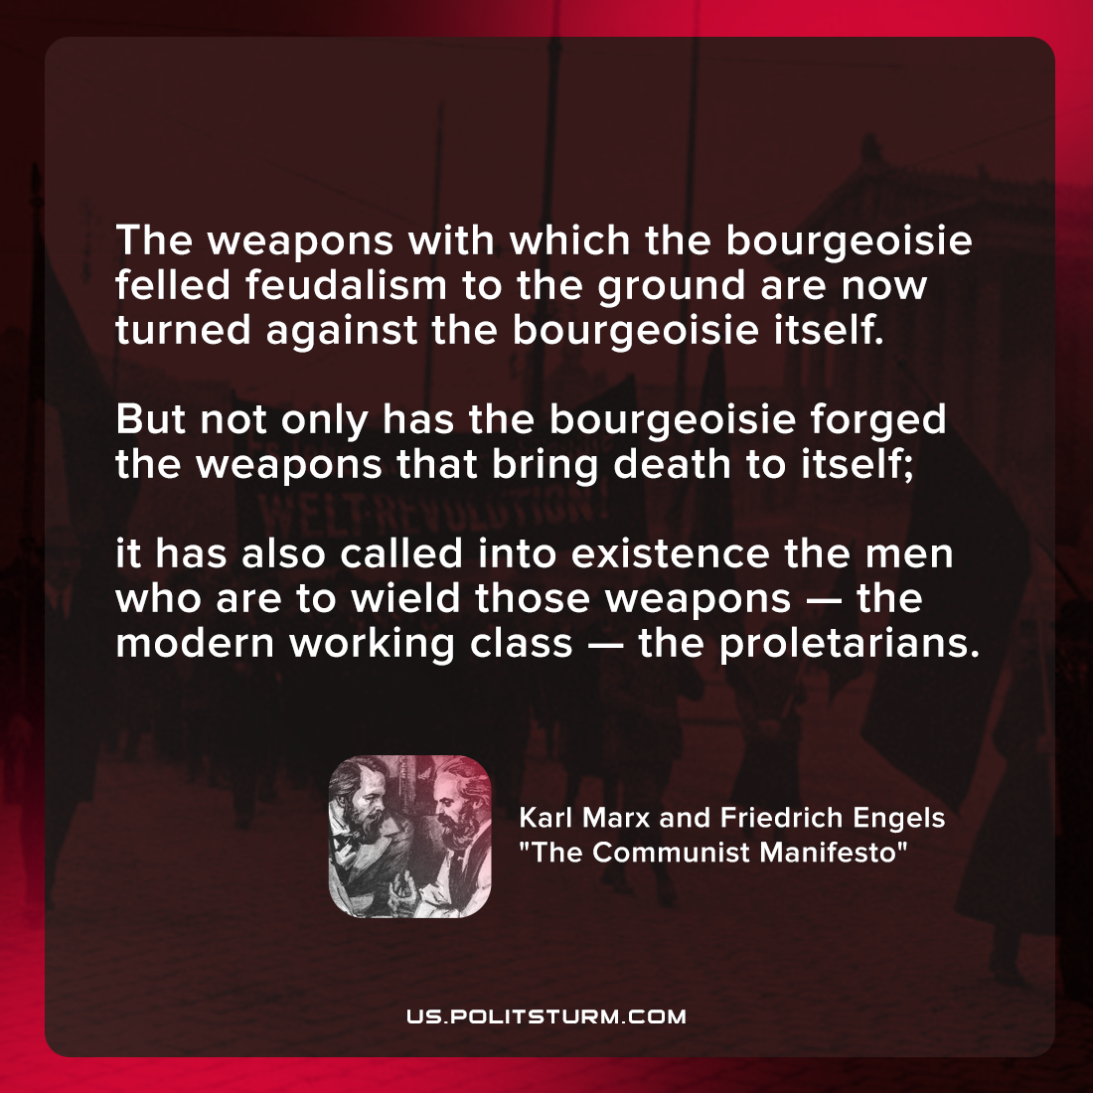

Original article
2022-01-07

The weapons with which the bourgeoisie felled feudalism to the ground are now turned against the bourgeoisie itself. But not only has the bourgeoisie forged the weapons that bring death to itself; it has also called into existence the men who are to wield those weapons — the modern working class — the proletarians.

Karl Marx and Friedrich Engels, “Manifesto of the Communist Party”

Original article

