Marx and Engels on the New Socio-Economic Formation
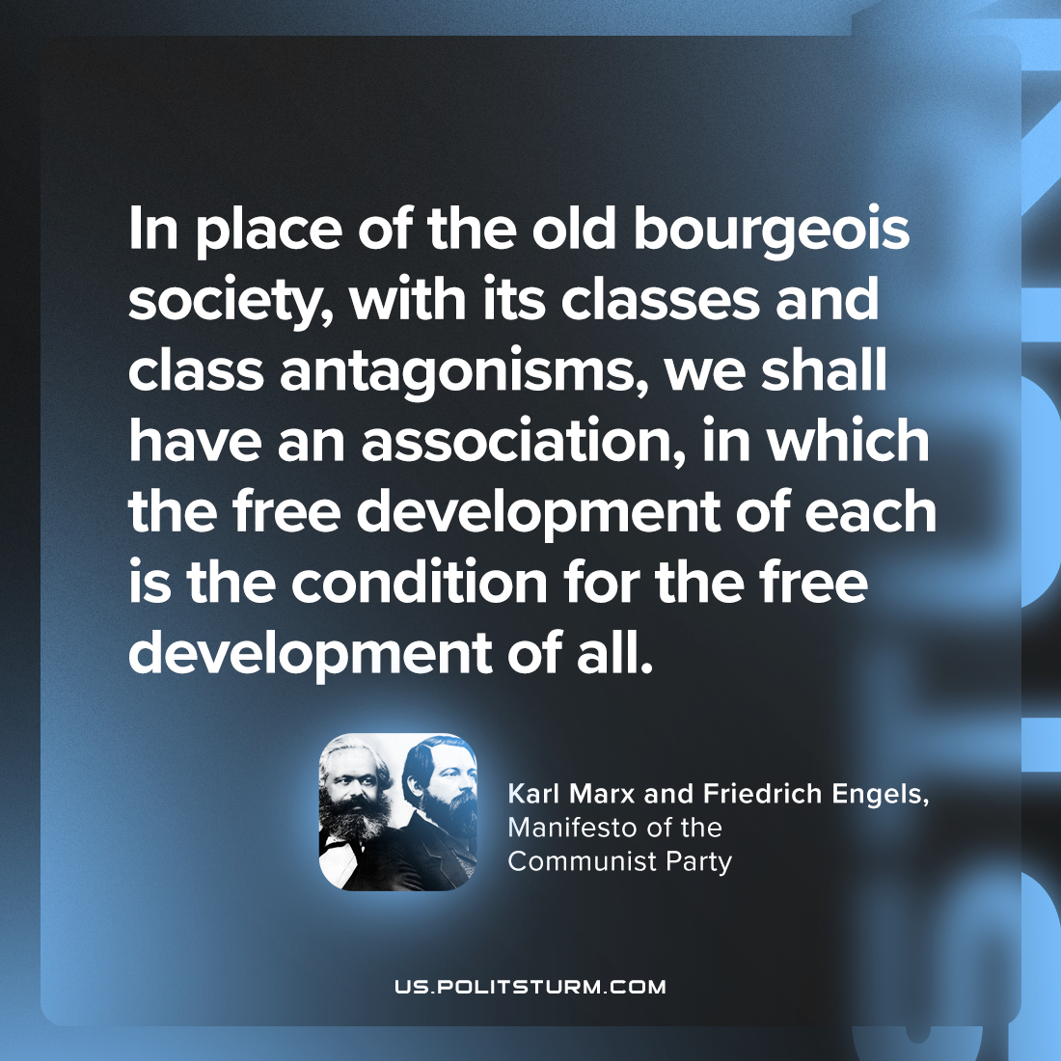

Original article
2023-11-14

"In place of the old bourgeois society, with its classes and class antagonisms, we shall have an association, in which the free development of each is the condition for the free development of all."
Karl Marx and Friedrich Engels, Manifesto of the Communist Party

Original article

